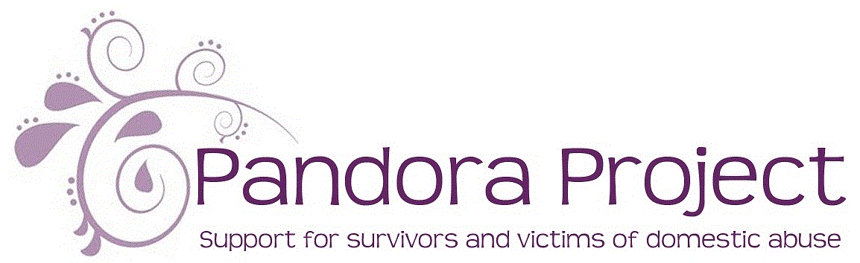

Referral form for Escape The Trap
TEENAGE RELATIONSHIP ABUSE PROGRAM

Referrer details

Name of referrer

Job role

Organisation

Email address

Phone number

Date of referral

Client Details

Name |  | Date of birth
Address

Client’s phone number | Parent’s phone number
Safe days and time to contact | Safe days and time to contact

Is CYP living with the perpetrator?

Details of other agencies involved with family

Details of Referral

Include brief history of domestic abuse and support needed

Parent’s Consent:

I consent to Pandora Project supporting my child around the impact of domestic abuse. Pandora Project will not share information without your consent, unless we have concerns about the safety of a child or adult.

Parent’s Signature:

…………………………………………..

Young Person’s Signature:

……………………………………….

Please return by email to: freedom@pandoraproject.org.uk

Or by post to: Pandora Project, PO Box 91, King’s Lynn, PE38 8BW

