Did you enjoy your journey?

Use your sticker to tell us how you feel about
our display

☺
😐
☹

You will find the smiley charts as you leave.

If you wish to make a comment on anything you have seen, please use the blank chart provided.

Thank you very much for visiting us.

Norfolk County Council

Putting Norfolk First

Royal Norfolk Show 2002

Wednesday 26 June
Thursday 27 June

Find out what you can gain from our services in Norfolk

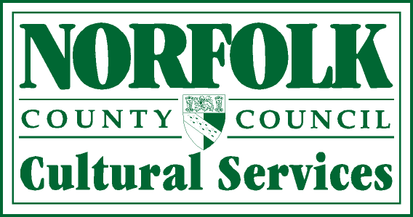

Learning throughout Life
Follow our guided path

Pre-school:
- Visit the Three Bears cottage
- Find out how you can become involved with your child’s learning

School:
- Find out how the Norfolk Record Office and museums support work in schools
- Have a go! Hands on Maths and Science
- Be challenged by the Study Support Team
- Join in the Arts workshops

School to work
- Find out about the new Connexions service giving advice and guidance to young people
- Find out about a career in childcare

Work
- Find out how you could support the youth service
- Learn about the different routes you can take to enter the teaching profession
- Search the web for childcare

Leisure/community
- Surf the net with libraries and Adult Education
- Find out about summer activities for young people
- Experience the excitement of flamenco dancers
Timetable for performances

10.00 – 10.30 Brain workout and dance

10.30 – 11.00 Tai Chi, Yoga, Flamenco, Egyptian dance or Indian Head Massage

11.00 – 11.30 Science at the Circus

11.30 – 12.00 Stories for all ages

12.00 – 2.00 Music from Norfolk Schools

2.00 – 2.30 Science at the Circus

2.30 – 3.00 Tai Chi, Yoga, Flamenco, Egyptian dance or Indian Head Massage

3.00 – 3.30 Stories for all ages

3.30 – 4.30 Tai Chi, Yoga, Flamenco, Egyptian dance or Indian Head Massage

