July 2007

Dear school,

Re: Norfolk Junior Academy Centres 2007

The Norfolk Junior Academy Centres are aimed at current county players & those currently performing just below county level. Last season’s county coaches/managers have sent me lists of those who represented Norfolk at each age group and invitations have been sent out to individuals who played in the U13 to U17 age groups for boys and girls. I am asking school to send in names and addresses of any players who they think would be eligible and of an appropriate standard to attend the centres.
The coaching programme for the academy centres will be developed by Simon Letchford and Lisa Wooding. Simon Letchford’s coaching achievements include: England U16 and 21 Coach, Wessex Leopards Coach (winners of first ever GB Super League), Centrally Contracted Coach employed by England Hockey, Chelmsford Ladies 1st XI Coach Slazenger English Hockey League Premier Division Indoor and Out, Reading University Coach, and partner of Hooked On Hockey. Lisa Wooding’s achievements include: current England & GB international with approx 75 caps, played for Saxon Tigers in the GB Super League, Chelmsford Ladies 1st XI player, Reading University Coach, and partner of Hooked On Hockey.
The centres will be delivered by local coaches and will be focusing on the development of individual core skills. The centres will also incorporate a selection of workshops e.g. Hydration & Nutrition, Injury Prevention & Management, and Kit Talks.
For goalkeepers there is an opportunity to be coached by former England & GB goalkeeper Simon Mason at the annual Dereham Hockey Club Goalkeeping Day, which will focus on goalkeeping fundamentals. Dereham HC has been running this event for 8 years, & this year they are working in partnership with Active Norfolk to enable us to offer this development opportunity to even more goalkeepers as part of the Norfolk Hockey Development Plan. If you would like more information on this course please get in touch.
The Junior Academy Centres will be held at Dereham HC; further information and directions will be sent out to applicants with their confirmation packs in the few weeks before the centres begin. Following attendance at the centres all participants will receive an invitation to the appropriate county trials for the 2007/08 season. Places are limited and will be allocated on a first-come first served basis. If you would like juniors from your school to attend please fill in the enclosed nomination form and return it ASAP. The centres cost £30 and the deadline for applications is Friday 27th July.
If you have any questions or would like more information please do not hesitate to contact me. I look forward to receiving your nominations.

Yours sincerely,
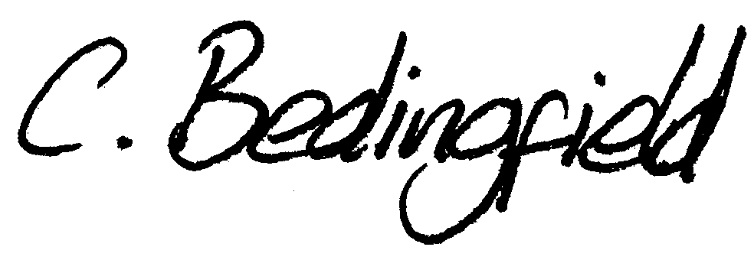
Connie Bedingfield
Norfolk Hockey Development Officer
Active Norfolk

Tel: 01603 723699

Mobile: 07785 724967
e-mail: connie.bedingfield@activenorfolk.org


Norfolk 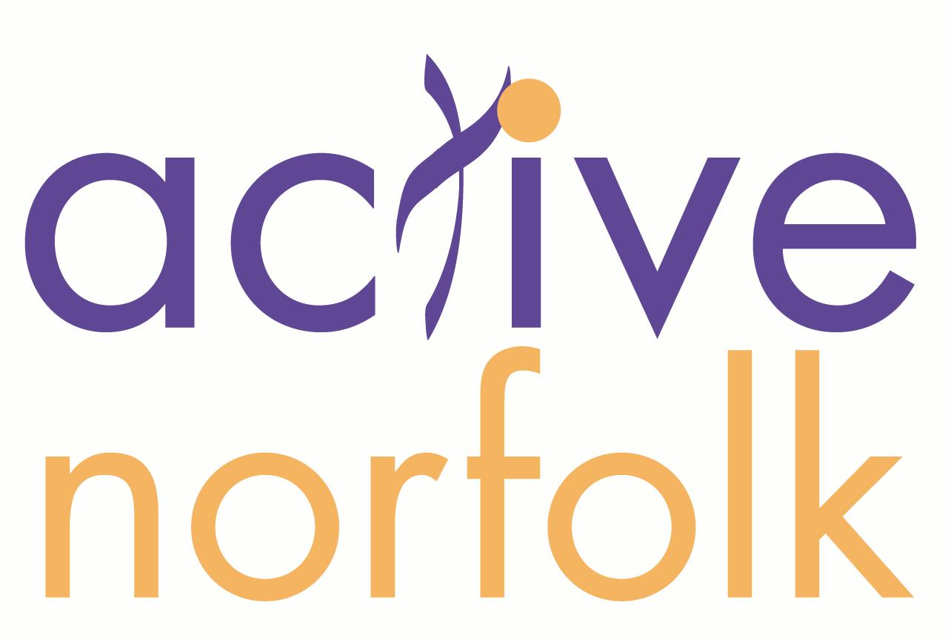
JUNIOR ACADEMY CENTRES 2007
Dereham Hockey Club

SCHOOL NOMINATION FORM

Name of School: ____________________

Please list below your school’s nominated players for the Norfolk Junior Academy Centres. As county players for the 2006/07 season have already been nominated by their age group coaches, please list other players who you think would be eligible and of an appropriate ability.

Date | Time | Age Group
Sat 25th & Sun 26th August | 10.00 – 15.00 | U14 boys & girls*
Sat 25th & Sun 26th August | 10.00 – 15.00 | U15 boys & girls*
Sat 11th & Sun 12th August | 10.00 – 15.00 | U16 boys & girls*
Sat 11th & Sun 12th August | 10.00 – 15.00 | U17 boys & girls*
* Note: If the applicant will be U14 of 1st Jan 2008 apply for the U14 group, if they will be U15 on 1st Jan 2008 apply for the U15 age group & so on. This is in line with the new England Hockey regulations that will apply to next season’s county squads.

Player Name: | Address: | Tel: | Age Group:

Please return this form ASAP to:

Connie Bedingfield
Norfolk Hockey Development Officer
Active Norfolk, Norfolk County Council, Turner Road Centre, Turner Road, Norwich, Norfolk. NR2 4HB
Tel: 01603 723699 Mobile: 07785 724967 e-mail: connie.bedingfield@activenorfolk.org

