Strategic Core
County Hall
Martineau Lane
Norwich
NR1 2DL

Minicom: (01603) 223833

Mrs Anne Dobson

SC/AD/MAH/02 01603 222071

6 June 2002 01603 223838

anne.dobson.edu@norfolk.gov.uk

To all schools with Reception Classes & Nursery schools

Dear Colleague

Re: Review of Policy for First Admissions to Schools and Admissions to Nursery Classes

The review of the policy for first admissions to school and arrangements for admissions to nursery classes was completed on 2nd April 2002, when the attached policy was agreed for all community and voluntary controlled schools. This admissions policy is also strongly recommended for adoption by all Voluntary Aided and Foundation Schools in Norfolk. The new policy will be implemented for admissions from September 1st 2003, and it is important that it is included in all documentation relating to school admissions from immediate effect. This is particularly important with regard to the school prospectus and any other information provided to parents. Further information will follow regarding changes to the administration of first admissions into school for September 2003.

We also attach an information sheet for the provision of places in Nursery Classes and Schools.

I also include a copy of a letter informing parents of the change to the Policy for First Admissions, which you may like to photocopy in order to inform the parents in your area of the proposed change.

We do not propose to grant any more exceptions to the current policy, but will be seeking to work closely with schools in ensuring that the transition to the new policy is as smooth as possible. We would welcome your comments and suggestions as to how this may be achieved in your area. If you have any queries or require further information please contact Anne Dobson (01603 222071).

Yours sincerely
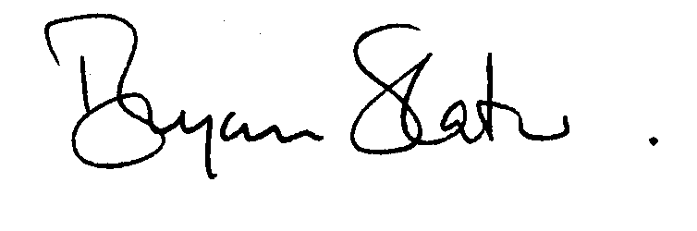
DIRECTOR OF EDUCATION

