Strategic Core
County Hall
Martineau Lane
Norwich
NR1 2DL

Minicom: (01603) 223833

Mrs Anne Dobson

SC/AD/MAH/04 01603 222071

6 June 2002 01603 223838

anne.dobson.edu@norfolk.gov.uk

Dear Parent

Re: Change to the policy on First Admissions to schools

Following the review of the policy for first admission to schools, the County Council adopted the following policy to take effect for admissions from 1st September 2003 for all Community and Voluntary Controlled Schools. Until that date the current policy remains effective.

By law children must start statutory education full time at the beginning of the term following their fifth birthday. Where admission is offered prior to compulsory school age, parents may defer their child’s entry into school until later in that academic year.

For Community and Voluntary Controlled Schools children born between 1st September and the end of February may start school full time at the beginning of the autumn term before their fifth birthday.

Children born between the 1st March and 31st August, may start school part time at the beginning of the autumn term before their fifth birthday and full time at the beginning of the spring term before their fifth birthday.

All settings offering free part-time early education places are now operating to the same Foundation Stage Curriculum, which continues throughout the Reception year in school. We hope that this change to the policy for first admission to school will give parents more freedom to decide on the best time for their child to make the transition from pre-school into school, based on the needs of their individual child. The Early Years Development and Childcare Partnership are also working with schools and pre-school settings to create more integrated childcare and education in each local area.

If you have any concerns or queries please contact your local early education provider, your local school or Anne Dobson (01603 222071).

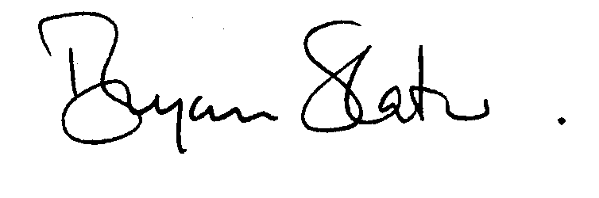Yours sincerely
DIRECTOR OF EDUCATION

