Fiona Musters

3 July 2002

To all schools with reception classes

Dear Colleague

Re: Statutory Assessment of Children in their First Year in School
Foundation Stage Profile - replacement of Baseline Assessment

You will have received this term a leaflet from the QCA (ref QCA /02/893) setting out some of the changes to the statutory assessment of children when they start school.

The new orders take effect from September 2002. The new Foundation Stage Profile will not be available until January 2003 and does not have to be completed until June 2003. However, in response to a number of queries we have had from schools it is felt some further guidance on what to do in September would be helpful.

Please find the attached guidance sheets.

If you have any queries or require any further information please contact Fiona Musters (01603 433276)

Yours sincerely

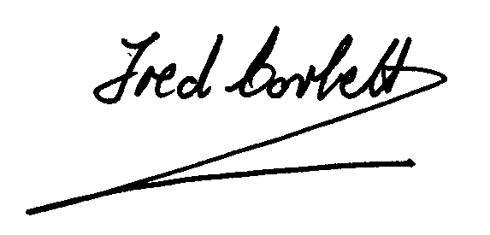

Fred Corbett
Assistant Director
(Advisory Services)

Foundation Stage Profile
The Foundation Stage Profile will replace statutory baseline assessment from September 2002.

The principles of the Norfolk Baseline Scheme and the new Foundation Stage Profile are the same; both are based on practitioners’ on going observations and assessments of the areas of learning. The transfer from one system to another should be relatively easy. Each child’s typical development and achievements will be recorded on assessment scales derived from the stepping stones and early learning goals.

Assessment on entry to school 2002/3

Gather information from parents and pre-school setting
Pre-school settings use a range of formats for recording children’s progress. Where the Norfolk Foundation Stage Assessment Document has been used in the pre-school or nursery, this may continue to be used in the reception class to note significant achievements, until such time as the Foundation Stage Profile material becomes available in the Spring Term 2003. Schools will need to seek the permission of parents to receive the pre-school records.

Some maintained nurseries use the Norfolk Baseline Scheme this may continue to be used this year to record achievements up until the time when the Foundation Stage Profile becomes available. Teachers need to be aware that the Norfolk Baseline Assessment Scheme is based on the desirable learning outcomes and therefore does not include all the early learning goals for communication, language and literacy and mathematics.

As in previous years, the information received from parents is important in helping to build a picture of what the child has already achieved. This information may be gathered through home visits, personal interviews, ‘All About Me’ booklets, as well as written records made by the preschool setting.

On entry to school
Bury infant check will continue to be used as the LEA’s SEN funding scheme.

There is no requirement for schools to use any other assessment scheme other than the new Foundation Stage Profile when it becomes available in the new year. Headteachers will want to be sensitive to the overall assessment load and will not want to burden practitioners and children unnecessarily.

While waiting for the distribution of the Foundation Stage Profile from the DfES, it is recommended that teachers use the existing recording system of the Norfolk Assessment Foundation Stage Record and maintain the established good practice of using on -going assessments to help them to plan teaching and learning.

On-going Assessment for Learning

Observing and talking with children have always been at the heart of assessment in the early years. Collecting and recording evidence of significant achievements helps to build a developing picture of children’s attitudes and understanding. Teachers need a range of strategies for collecting information gained during normal day to day classroom activity. The following strategies are familiar to teachers who have effectively used the Norfolk baseline assessment in recent years;

Focussed adult directed activities

Children assessed by an adult, against pre-selected criteria

Focused child initiated activities
Children assessed while the adult engages in playing alongside

‘Catch as you can’ observations

Written on ‘post its’ or on to clipboards setout around the classroom

- Self assessment
Children talking about their learning with photographs or pictures as prompts

- Timed observations 30 minutes
Children assessed at intervals for choice of activities and interaction.

Information from these assessments may be held to await the arrival of the Foundation Stage Profile or recorded on to the Norfolk Foundation Stage Assessment Document.

How will we be able to show value added in the reception year?
From the academic year 2003/4, this could be achieved by reception teachers completing a first recording on the Foundation Stage Profile in the first half of children’s first term in reception, after allowing time to settle in their new classes. These scores might be compared with the final score at the end of reception year. Only final scores will be collected nationally.

What training will be available?

Training opportunities for assessment practice in the early years and the new Foundation Stage Profile may be found on flyers sent to school or on the web site http://advisoryservice.norfolk.gov.uk

How will the Foundation Stage Profile judgements be moderated?
Moderation will be integral to the scheme for which LEAs will be responsible. Further guidance on the process of moderation will be available when the scheme is published.

