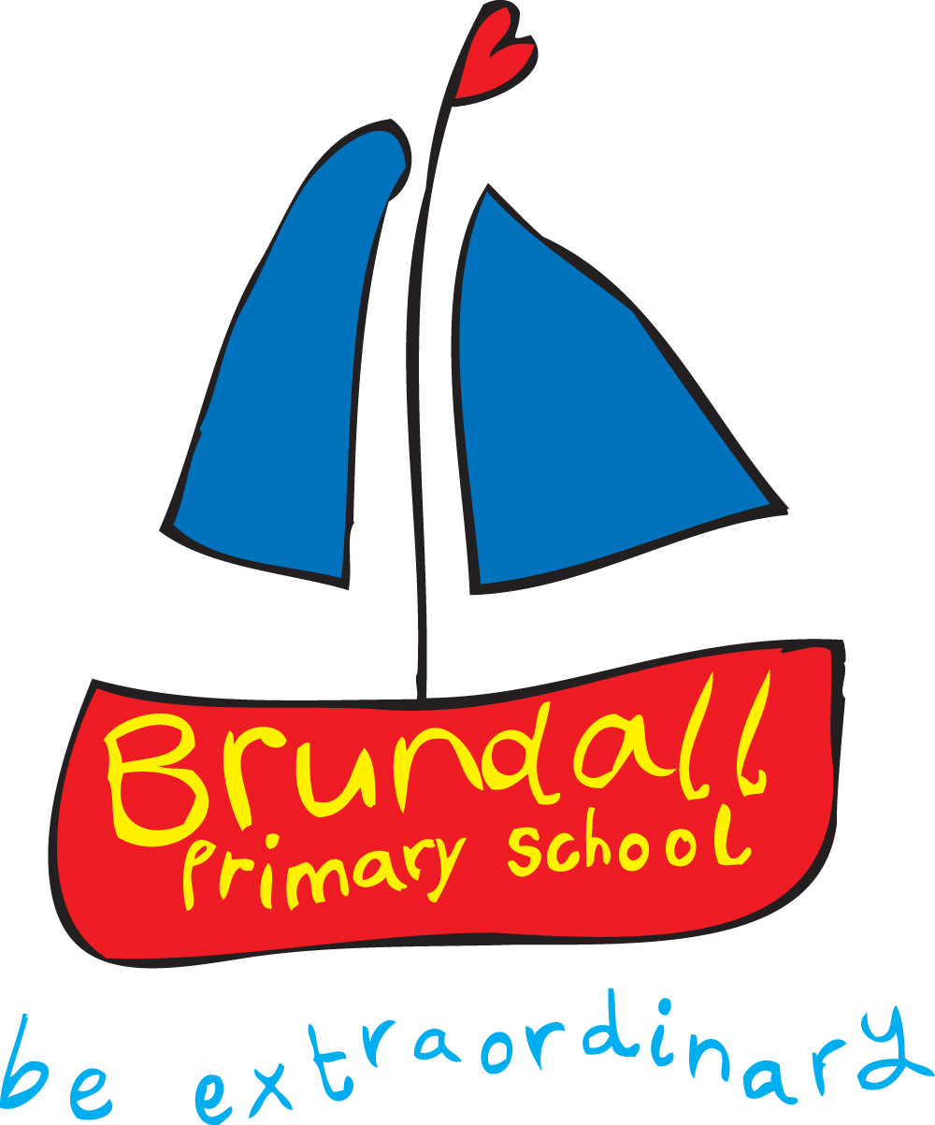

Come and share a day with us at
Brundall Primary School

Building Learning Motivation from the Earliest Years
(Creating a Primary classroom climate which supports independence,
learning resilience and intrinsic motivation)

A wonderful opportunity to hear

Dr. Barry Hymer

“This challenging and stimulating one-day training event will explore the roots of intrinsic learning motivation in the primary years. Drawing on the research evidence of people such as Prof. Carol Dweck, it will focus on ways of delivering messages and mindsets that lead to
long-term learning through challenge and risk taking, whilst avoiding the seductive
and harmful use of product-praise and emphases on short-term performance.
Whilst the day will be couched in a strong research-led and theoretical framework, its orientation will be focused on the primary classroom, with plenty of opportunities for personal reflection and individual and group action planning – and fun!”

17th October 2008
9.00 a.m. – 3.30 p.m.

Unbeatable value at £50 per delegate (including lunch and refreshments)
Group bookings of 5 persons £200
Booking telephone: 01603 712597 e-mail: office@brundall.norfolk.sch.uk

Barry, an experienced teacher and chartered psychologist, is the Director of Still Thinking (UK) Ltd. & author of educational material. He holds the position of Visiting Fellow at Newcastle University’s Centre for Teaching and Learning, is Consultant Editor for the journal Gifted Education International and is a national trainer for Osiris Educational & for SAPERE (The Society for the Advancement of Philosophical Enquiry and Reflection in Education). He has delivered keynote and workshop presentations at numerous national & international conferences.
Barry has served on the National Committee of NACE (the National Association for Able Children in Education), and for five years was the book review editor for the NACE journal Educating Able Children. In 1999 Barry was asked to provide oral & written evidence to the House of Commons Select Committee Inquiry into the education of able children. He has also been an Associate Tutor at Oxford-Brookes University. In 2003 Barry’s work received international recognition when he received the ICPIC (International Council for Philosophical Inquiry with Children) Award for Excellence in Interpreting Philosophy with Children. The citation for this award noted that his work “Speaks to the richness of children’s imaginative play and their ability to stretch sensory images to the fullest”.

Barry lives on the borders of North Yorkshire, Cumbria and Lancashire with his wife and daughters. His passions for Van Morrison, walking, wild camping, chess, poultry-keeping and foraging for edible fungi, are only minimally shared by other members of his family.

