Children’s Services
School Workforce Remodelling
County Hall
Martineau Lane
Norwich
 |  | Norfolk NR1 2DL
 |  | Tel: 0844 800 8014
 |  | Fax: 01603 219050
Date: 8th April, 2005 |  | Minicom: 01603 223833
 |  | Email: dudley.whittaker@educ.suffolkcc.gov.uk
Please ask for: | Dudley Whittaker | Your ref:
Contact Number: | 01284 352154 | My ref:

To: Headteachers of all Norfolk Secondary Schools

Dear Colleague,

School Workforce Remodelling

The Introduction of Teaching & Learning Responsibility Payments
Secondary School Half-Day Conference: Thursday, 19th May, 2005
Wensum Valley Hotel, Taverham, Norwich

You will no doubt be aware that these payments will replace Management Allowances by December 2008 - see MI 57/05 in e-courier issue 126.

Schools will be expected to start this process of change in this coming Autumn Term. There are major implications for Secondary Schools and as a result I have arranged a half-day conference on Thursday, 19th May, 2005 at Wensum Valley Hotel, Beech Road, Taverham, Norwich (location map attached), starting at 09:15 with coffee/tea from 08.45. It will end at 12:00 noon followed by lunch.

The Principal Speaker will be Irene Dalton of national SHA who led last year’s informative briefing on Workforce Remodelling.

You are invited to attend this important conference and I would be grateful if you would respond to Virginia Wakely, Remodelling Support Officer, no later than Friday 22nd April, by completing and returning the attached booking form.

Yours sincerely

Dudley Whittaker
Workforce Remodelling Project Leader (Secondary)
WENSUM VALLEY HOTEL
Beech Avenue
Taverham
Norwich
NR8 6HP
Tel: 01603 261012

Directions:
From Norwich take the A1067 Fakenham Road. After entering Taverham, Beech Avenue is the third left, after the Jet garage.
From the A47 southern bypass follow the sign to Swaffham. At the end of the bypass you will approach a roundabout. Take the 3rd exit to Ringland. You will then come to a T-junction, turn left, follow the road to another T-junction, turn left again, follow the road round and over a bridge. Take first turning left after the bridge. We are 100 yards on the left.
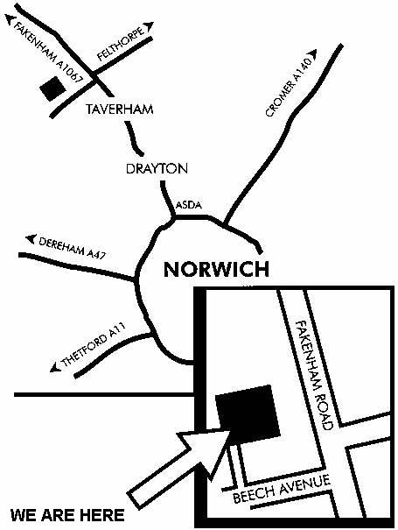



HALF-DAY CONFERENCE FOR SECONDARY SCHOOLS

The Introduction of Teaching & Learning Responsibility Payments

Thursday, 19th May, 2005
at Wensum Valley Hotel, Taverham, Norwich

SCHOOL:………………………………………………………………………

Who will attend Headteacher

(please tick) and/or

Deputy Head

and/or

Member of Finance Team

Delegate(s) names
(in capitals)

Headteacher ……………………………………………………………….

Deputy Head ………………………………………………………………

Member of Finance Team ……………………………………………….

I / we will stay for the luncheon after the conference:

Yes/No

Cost: Free of charge.

How to book:

Save this form to your computer. Complete and save again, then send as an e-mail attachment to:

virginia.wakely@norfolk.gov.uk

or fax to 01603 219050.



by Friday, 22nd April, 2005.

