
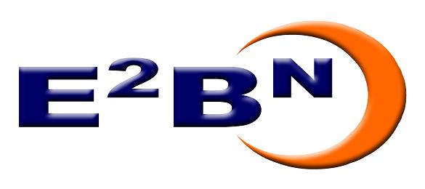

E2BN and DfES Road shows
Embedding learning platforms in the curriculum

21st February 2006 - Icknield High School, Luton, LU3 2AH
7th March 2006 - Priory Centre, St Neots, PE19 2DN
17th March 2006 - Moot Hall, Colchester, CO1 1FR
27th March 2006- John Innes Centre, Norfolk, NR4 7UH

E2BN (the East of England Broadband Network), in partnership with the DFES, Becta and NCSL, will be running a series of educational road shows focusing on the potential of learning platforms for transforming teaching and learning.

The event is aimed at head teachers, deputy head teachers, AST’s at primary and secondary level; service managers, local authority improvement managers and regional school improvement managers. The workshops and seminars will provide a comprehensive overview of learning platforms and inform delegates why 20 million pounds investment has been allocated in the next financial year.

The sessions will cover both primary and secondary education, and will focus on the potential of learning platforms in raising standards and improving access. The sessions will also cover funding, national and local strategies and the facilities available to support schools. The topics covered will include:

- National strategy, deployment and funding
- Practical advise on the provision and support available at regional and local level
- How learning platforms can be embedded into the curriculum
- The potential for raising standards in literacy and numeracy as well as other curriculum areas
- The importance of learning platforms in supporting agendas such as ECM and anytime learning

A provisional agenda is attached. If you are interested in attending this event please complete the booking form and return to:

Pauline Adams
E2BN
Russell House
14 Dunstable street,
Ampthill
MK45 2JT

email: adams.pauline@gmail.com
Fax: 01525 405128

AGENDA

To give more people a chance to attend, the road shows will be repeated morning and afternoon. A lunchtime exhibition and demonstration of the technologies on offer through the RBC and LEAs will be open to both morning and afternoon attendees, including an opportunity for delegates to try out the facilities.

9:00/13:30 Introduction and aims of the day
-Paul Springford, Chair of E2BN learning and Teaching Group

9:10/13:40 The potential of Learning platforms, national strategy and funding
- DFES

9:30/13:50 Learning Platforms an overview and case studies
- Becta

10:00/14:20 E2BN Provision
- Chris Kastel, CEO E2BN

10:10/14:30 Q&A –A chance for delegates to put their initial questions to DfES, Becta and E2BN

10:30/14:50 Coffee

11:00/15:20 Round Robin – a chance for delegates to spend 15 minutes at any four of 6 sessions that will be repeated as groups of delegates move around. This will give more chance for exploration of different aspects and Q&A. The sessions will include input from schools, LEAs and the RBC and cover:

Potential of Leaning Platforms -Primary
Potential of Learning Platforms – Secondary
Learning platforms and DIDA
Regional strategy – E2BN’s Learning Exchange
Role in supporting national agendas e.g. ECM, anytime access
An LEA perspective – strategies and support at local level

12:00/16:20 A chance to look at one aspect in more detail – delegates can choose from:

Funding and deployment policy –DfES
Technical aspects and developments DfES
Current provision RBC – hands on session
Training and embedding – NCSL

12:45 Lunch and E2BN Learning Exchange exhibition (focusing on regional provision -Netmedia, Digitalbrain and the E2BN Learning Exchange)

Booking Form

Please fill in and return to:

E2BN
Russell House
14 Dunstable Street
Ampthill
Bedfordshire
MK45 2JT

Name:
Position:
Organisation:
Please tick which phase you are interested in:

Primary: |  | Secondary: |  | Both:
Please tick which event you wish to attend:

21st February 2006 - Icknield High School, Luton
7th March 2006 - Priory Centre, St Neots
17th March 2006 - Moot Hall, Colchester
27th March 2006- John Innes Centre, Norfolk

