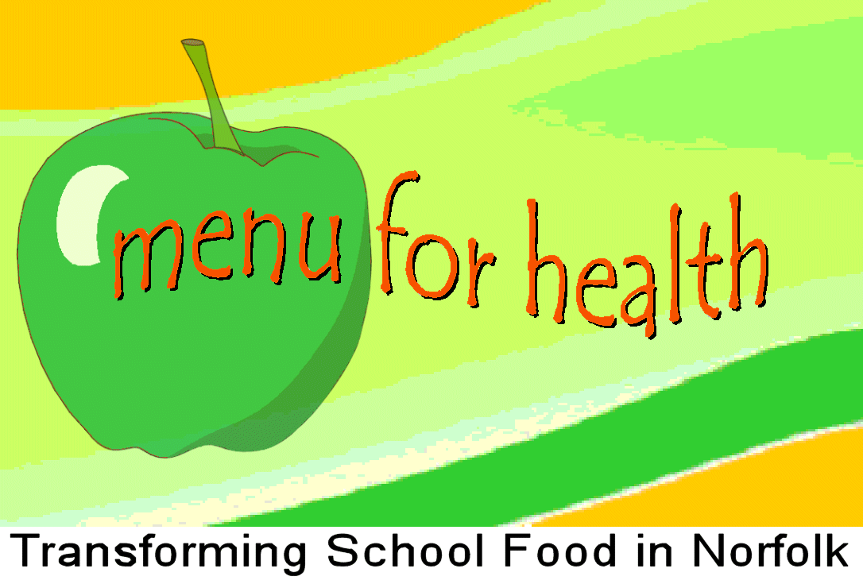

Transforming School Food in Norfolk

Healthy Norfolk Schools
St. Andrew’s House, Northside,
St. Andrew’s Business Park
Thorpe St. Andrew

Norwich, NR7 0HT

Tel: 01603 307242
Dept Fax: 01603 307188
louise.flynn@norfolk.nhs.uk
sue.astbury@norfolk.nhs.uk

Date: 18 June 2007

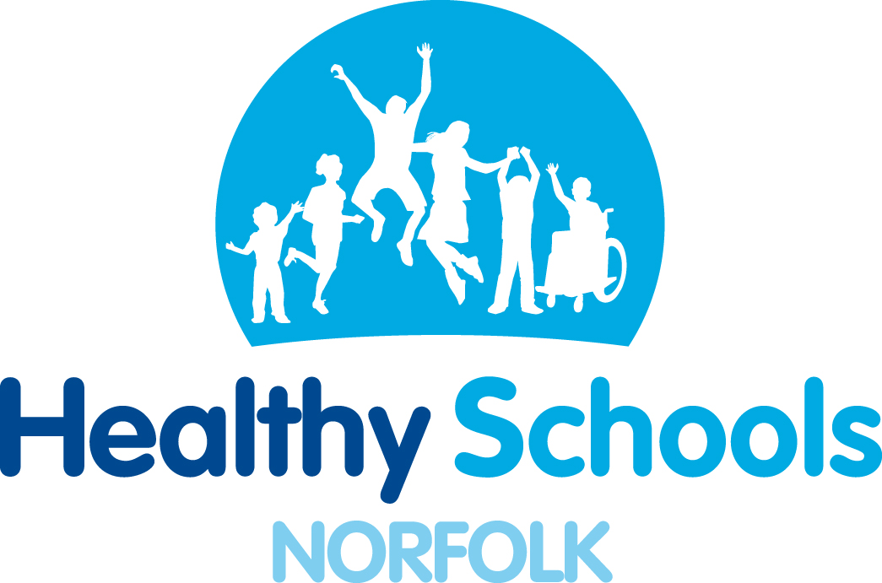

TO: All Norfolk Primary Schools

Dear Headteacher

‘Food Glorious Food’

Norfolk’s food festival for primary school children

We are writing to invite you to take part in this First Ever event to be organised by Norfolk Healthy Schools, which will be taking place at the John Innes Institute, Norwich on Thursday September 27th 2007 from 10am-2pm. This is a free event for 100 Norfolk Primary schools but you will need to organise your own transport and supply cover.

What is this day about?
The aim of this event is to inform, enthuse and inspire children about different aspects of food and nutrition.

What will the day entail?
There will be a variety of different interactive activities relating to food and nutrition. These include investigating what happens to the food in your body, cookery demonstrations and tasting, finding out more about different foods and their origins. The children will have a pack of useful information and activities that can be used in their school.

Who should attend?
In order to accommodate as many primary schools as possible we are asking schools to bring along 2 children to act as food ambassadors in their school.
They could be children who will be on the school council or SNAG.
They will need to be accompanied by one adult who will be able to help the children take this work forward in their school.

Cont….




What to do now
We have included a flier/poster for you to display in school along with a booking form for you to complete and fax back no later that September 7th. N.B the bookings will be taken on a first come first served basis so we encourage you to reply as soon as possible.

If you require any further information about this exiting day we would be pleased to hear from you. Contact the team on 01603 307242 or via email louise.flynn@norfolk.nhs.uk.

Healthy Norfolk Schools
Transforming School Food
Project coordinator.

Please reply no later than
Friday 7 September

FAO: Louise Flynn

We would like to book a place for our school to attend:

‘Food Glorious Food’

Norfolk’s food festival for primary school children
John Innes Institute, Norwich
Thursday September 27th 2007
10am-2pm

School Name:_____________________________________

Delegate information:

Adults name:

Title________FirstName:____________________Surname:__________________

Children’s Names:

First name:_______________________ Surname:__________________Yr_____

First name:_______________________ Surname:__________________Yr_____

If any of your group have dietary or access requirements please give details here:

____________________________________________________________________

Post or fax your booking form to Louise Flynn at:

FAX: 01603 307188

Post:
Louise Flynn, Healthy Norfolk Schools, St Andrews House, Northside, St Andrews Business Park, Thorpe St Andrew, Norwich, NR7 OHT

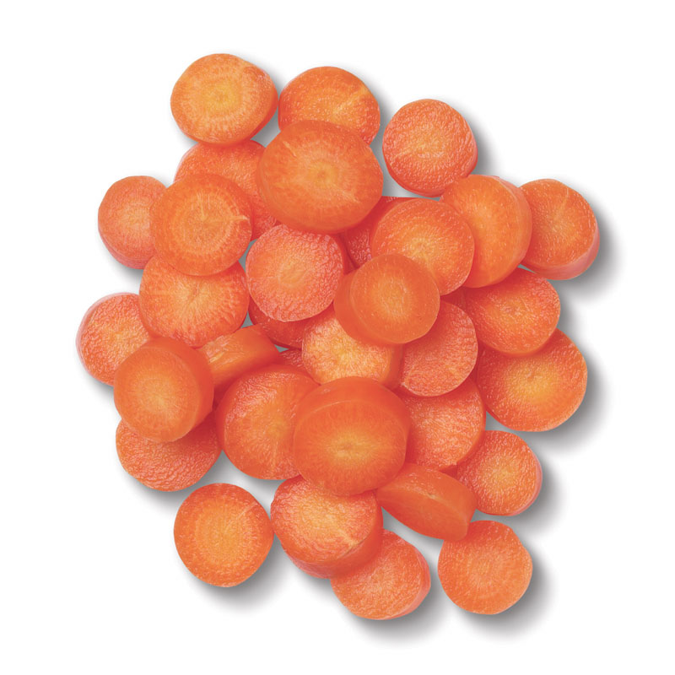

We would like to invite one adult and
two children from your primary school to attend:

‘Food Glorious Food’


A Food Festival for Children
27th September 2007
John Innes Centre
Norwich
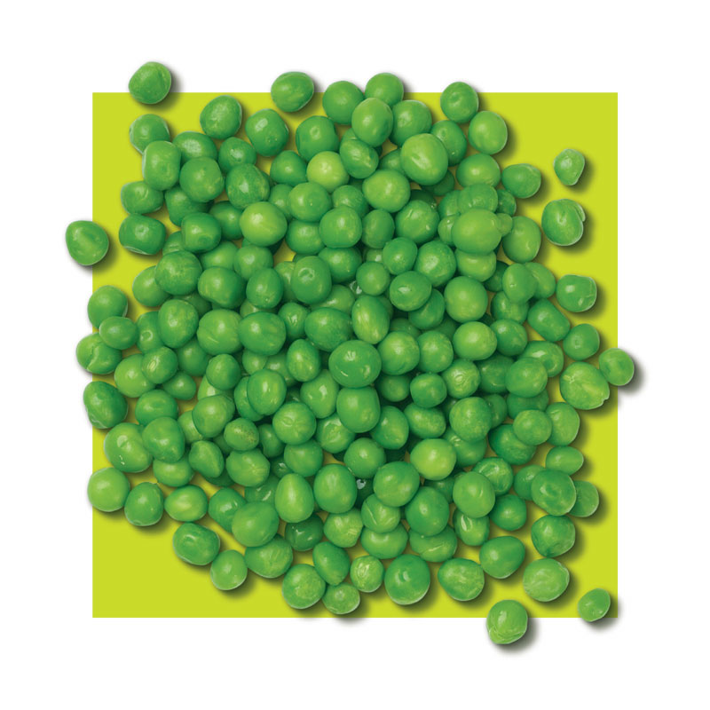

This fun and informative day has been organised to
enthuse and inform children about all aspects of food.
This will empower them to take information back to school
to work with their school council and SNAG groups.

Find out more about milk!


Discover interactive stands and displays.
Come and see the Captain Carrot Show.
Tickle your taste buds - live cookery demonstrations and food tasting.
Find out how well you wash your hands.
Useful resources and activities.
Quizzes, fun, games and more.

Booking information:
Please complete the booking form sent to your school with this poster or contact:
Louise Flynn, Healthy Norfolk Schools 01603 307242 or email louise.flynn@norfolk.nhs.uk

