For the attention of the Headteacher and colleagues promoting the International dimension
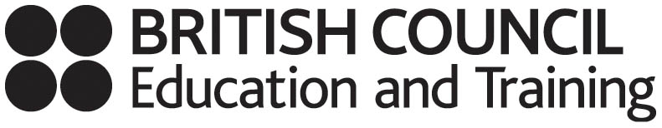
East of England Regional Professional Development Network


- Is the International Dimension on your School Improvement Agenda?
- Would it help to hear about models of good practice and opportunities for curriculum enrichment?
International shared learning motivates students, raises standards and contributes to the five “Every Child Matters” outcomes


The day will include:
- Exciting on-line shared learning opportunities for students available 24:7
- International professional development opportunities
- Lots of examples of approaches to international shared learning
- Gaining accreditation for international work
- Inputs about Global Learning Communities and the Global gateway – the DfES funded British Council “one-stop shop” to access information on international work
- Making foreign languages relevant and exciting in school
Thursday 23 November 2006 from 10.30 to 15.30
Abington Hall, Little Abington, Cambridge

I confirm that I would like to attend the East of England Global Learning Day on behalf of my school. [There is no charge for this event].

First name:……………………….Surname:………………………………Role:……………………………..

Email address: …………………… School: ……………………………Tel No: …………………………….

Which aspects of international work interest you most?: ……………………………………………………

……………………………………………………………………………………………………………………..
Please return this acceptance form to Alison Cunningham, Room 20 County Hall, Martineau Lane, Norwich,
NR1 2DL, or email to alison.cunningham@norfolk.gov.uk by 20th October at the latest

