Children’s Services
County Hall
Martineau Lane
Norwich
 |  | Norfolk NR1 2DL
 |  | Tel: 0844 800 8001
 |  | Fax: 01603 223838
 |  | Minicom: 01603 223833
 |  | Email: alison.cunningham@norfolk.gov.uk
Please ask for: | Mrs A Cunningham | Your ref:
Contact Number: | 01603 223480 | My ref: | ACu01

27 October 2006

To the Headteacher
All Schools.

Dear Colleague,

International Education Week – 13 – 17 November
and International School Award.

The above week marks the fourth year that the DfES has designated an International Education Week to emphasise the benefits of internationalism and cultural diversity in the curriculum. It is an ideal opportunity for schools to celebrate the many exciting projects which are currently taking place in our schools and I know that many schools have events planned which highlight their international work.

I am hoping that we can put together a publication celebrating International Education Week in Norfolk and would be very grateful if you could let me have details (and pictures if available) of anything which takes place in your school.

‘Putting the World into World Class Education’ is the DfES strategy for International Education which was launched in 2004. It identifies the International School Award, administered by the British Council as a key indicator for recognising excellence in the integration of internationalism in school. Over time the DfES would like all schools to gain the International School Award and a milestone of 1000 schools by 2006 has been set.

In Norfolk there are currently 9 secondary and 6 primary schools which either have the full International School Award or are involved at either Foundation or Intermediate Stage.

International Education Week – 13 – 17 November
and International School Award.

I am sure that there are many others currently engaged in international activities who could already claim to be at Foundation or even Intermediate Stage. To find out more about the International School Award visit www.globalgateway.org/isa

The British Council is organising a free regional conference to promote the international dimension near Cambridge on Thursday 23 Novembers (flyer attached). I will be arranging for a minibus from County Hall, so free transport will be available for those who sign up early. Please contact Janine Birt on 01603 223905 to book a place.

One of the first tasks for any school intending to pursue the International School Award is to designate a member of staff as an International Co-ordinator, and I know that many schools have already done this.

I would be very grateful if you could let me know the name of your International
Co-ordinator so that I can make sure any information about international education can be sent to the most appropriate person.

Please do not hesitate to contact me if you wish to know more about international education, International School Award or Norfolk’s existing strategic links with partners in France China and Norwich.

Yours sincerely

Alison Cunningham
School Development Officer (and International links)

Name of School:

Name of International Co-ordinator:

Email address:

International Education Week 2006

Description of activities/events

Please return to Janine Birt (janine.birt@norfolk.gov.uk) , Children’s Services (Room 20), County Hall, Martineau Lane, Norwich, NR1 2DL or fax to 01603 223838.
For the attention of the Headteacher and colleagues promoting the International dimension
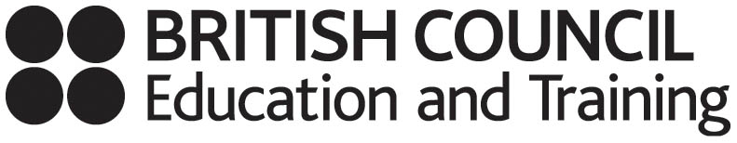
East of England Regional Professional Development Network
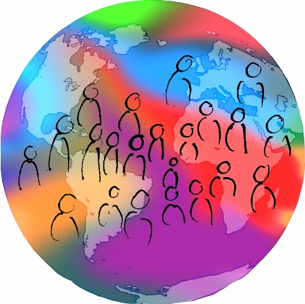

- Is the International Dimension on your School Improvement Agenda?
- Would it help to hear about models of good practice and opportunities for curriculum enrichment?
International shared learning motivates students, raises standards and contributes to the five “Every Child Matters” outcomes


The day will include:
- Exciting on-line shared learning opportunities for students available 24:7
- International professional development opportunities
- Lots of examples of approaches to international shared learning
- Gaining accreditation for international work
- Inputs about Global Learning Communities and the Global gateway – the DfES funded British Council “one-stop shop” to access information on international work
- Making foreign languages relevant and exciting in school
Thursday 23 November 2006 from 10.30 to 15.30
Abington Hall, Little Abington, Cambridge

I confirm that I would like to attend the East of England Global Learning Day on behalf of my school. [There is no charge for this event].

First name:……………………….Surname:………………………………Role:……………………………..

Email address: …………………… School: ……………………………Tel No: …………………………….

Which aspects of international work interest you most?: ……………………………………………………

……………………………………………………………………………………………………………………..
Please return this acceptance form to Alison Cunningham, Room 20 County Hall, Martineau Lane, Norwich,
NR1 2DL, or email to alison.cunningham@norfolk.gov.uk

