Norfolk Extended Schools
Children’s Services
Room 117, County Hall
Martineau Lane

Norwich NR1 2DL
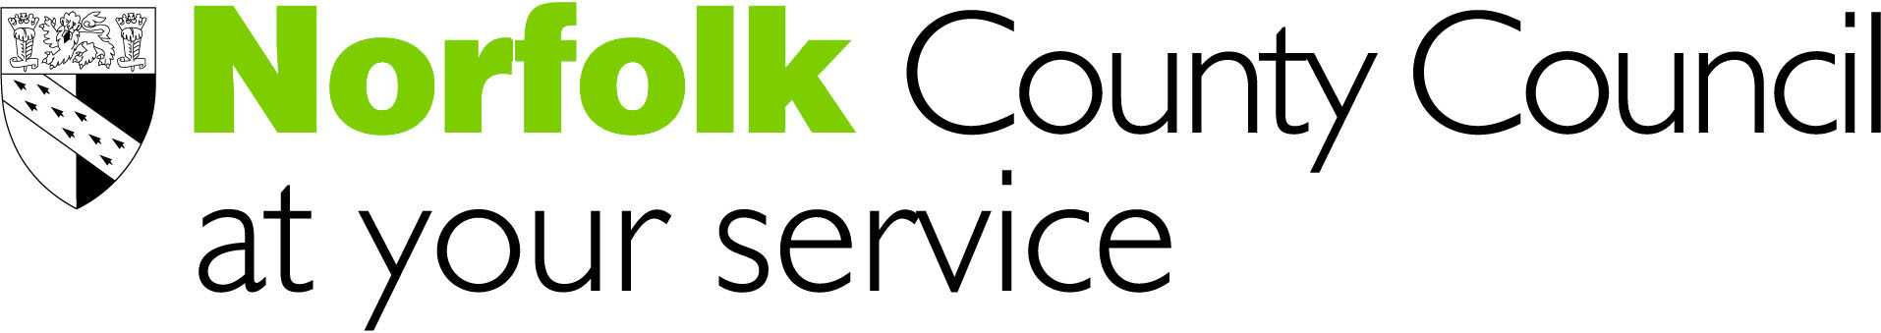

Extended Leadership for Extended Schools

A seminar for head teachers, and managers of organisations that work with children and young people

“Moving from vertical silos to horizontal services”

Speaker: Professor John West-Burnham

Date: Friday 7 October 2005
Time: 9.45 am – 3.30 pm
Venue: Norwich Professional Development Centre

Cost: FREE OF CHARGE
(Places will be allocated on a first come first served basis)

There are implications for leaders and managers of many organisations in the emerging map of the future. This seminar aims to help us develop our thinking and inform our actions.

This event will explore aspects of leadership including:

- strategies
- behaviours
- skills

that apply to community leadership

Booking form attached

Linked to Norfolk County Council Leadership Academy

Linked to Norfolk County Council Leadership Academy
Norfolk Extended Schools

Children’s Services
Room 117, County Hall
Martineau Lane
Norwich NR1 2DL
Tel: 01603 222361

Extended Leadership for Extended Schools

Friday 7 October 2005
9.45 am – 3.30 pm
Norwich Professional Development Centre, Woodside Road, Norwich

Name(s):
School/Organisation:
Address:
Telephone No:
Special dietary requirements

Please return this form to:

Jean Bain
Norfolk Extended Schools
Room 117, County Hall
Martineau Lane
Norwich NR1 2DL

Fax: 01603 228983

Email: extendedschoolsenquiry.edu@norfolk.gov.uk

Closing date: Wednesday 28 September 2005

Cancellation Policy

- If a delegate cancels their place after Wednesday 28 September or fails to attend the seminar a charge of £25 will be made.

- It is possible at any time to nominate a substitute delegate. Please inform us of any substitution.

