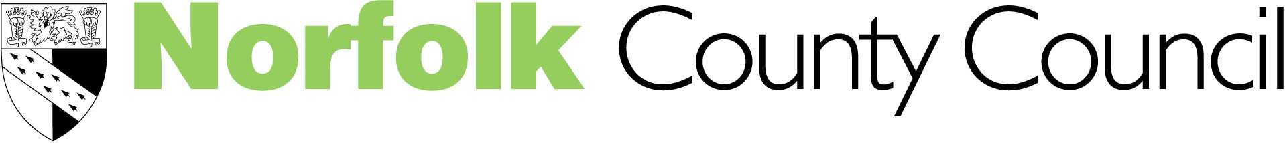
Children’s Services

"So Sad, so Young... so Listen!"

Philip Graham & Carol Hughes

Understanding and supporting Mental Health in Schools

“Mental health is everybody’s business”

Tony Blair, 1997

Come and join the Psychological Health & Emotional Well-Being Team, EPSS at the Pupil Referral Unit, Brooklands Centre, Magdalen Way, Gorleston for five twilight sessions to raise your awareness and provide strategies for supporting children and young people with mental health concerns. These sessions are appropriate for teachers of children from Year 5 upwards.

- Thursday, 4th October 4-6pm Understanding and supporting Mental Health in Schools (Rita Adair, Senior Educational Psychologist)
- Thursday, 11th October 4-6pm Eating Disorders (Jane Sarmezey, Educational Psychologist and Jo Seymour, Systemic Family Therapist)
- Thursday, 1st November 4-6pm Anxiety and Stress (Ian Mann, Educational Psychologist and Rita Adair, Senior Educational Psychologist)
- Thursday, 8th November 4-6pm Depression (Rita Adair, Senior Educational Psychologist)
- Thursday, 15th November 4-6pm Self Harm (Chris Ducker, Educational Psychologist)

Cost of all five sessions = £80 Cost for 1 session = £20

Please complete the slip below if you would like to attend and return with your payment or Journal Number
…………………………………………………………………………………………………………………………………………………
I would like to attend all five sessions
Or (tick boxes appropriately)

Thursday 4th October Thursday 8th October Thursday 1st November

Thursday 8th November Thursday 15th November
Name ………………………………………………………………………………………..

Title ………………………………………………………………………………………….

School/Address ……………………………………………………………………………

Please return your reply slip to: Heather Haycox, The Terrapin, Hewett School site, Cecil Road, Norwich, Norfolk NR1 2TJ by 28th September 2007 or email heather.haycox@norfolk.gov.uk. If you require further details contact Rita Adair on rita.adair@norfolk.gov.uk. (Tel: 01603 671400) 

