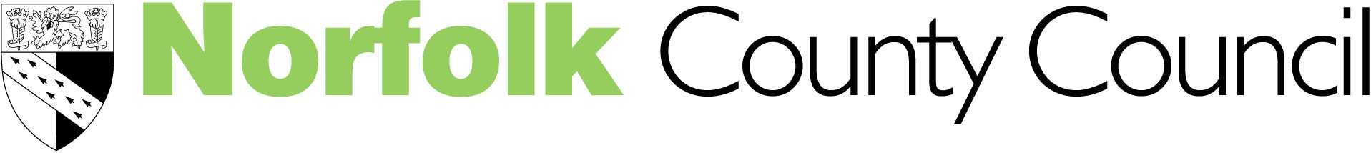
Children’s Services

"So Sad, so Young... so Listen!"

Philip Graham & Carol Hughes

Understanding and supporting Mental Health in Schools

“Mental health is everybody’s business”

Tony Blair, 1997

Come and join the Psychological Health & Emotional Well-Being Team, EPSS at Toftwood Community Junior School, Westfield Road, Dereham, NR19 1JB for five twilight sessions to raise your awareness and provide strategies for supporting children and young people with mental health concerns. These sessions are appropriate for teachers of children from Year 5 upwards.

- Thursday, 24th January 2008 4-6pm Understanding and supporting Mental Health in Schools (Rita Adair, Senior Educational Psychologist)
- Thursday, 31st January 2008 4-6pm Eating Disorders (Jane Sarmezey, Educational Psychologist and Jo Seymour, Systemic Family Therapist)
- Thursday, 7th February 2008 4-6pm Anxiety and Stress (Ian Mann, Educational Psychologist and Rita Adair, Senior Educational Psychologist)
- Thursday, 21st February 2008 4-6pm Depression (Rita Adair, Senior Educational Psychologist)
- Thursday, 28th February 2008 4-6pm Self Harm (Chris Ducker, Educational Psychologist)

Cost of all five sessions = £80 Cost for 1 session = £20

Please complete the slip below if you would like to attend and return with your payment or Journal Number
…………………………………………………………………………………………………………………………………………………
I would like to attend all five sessions
Or (tick boxes appropriately)

Thursday 24th January Thursday 31st January Thursday 7th February

Thursday 21st February Thursday 28th February
Name ………………………………………………………………………………………..

Title ………………………………………………………………………………………….

School/Address ……………………………………………………………………………

Please return your reply slip to: Helen Stubbs or Michele Blazey, The Terrapin, Hewett School site, Cecil Road, Norwich, Norfolk NR1 2TJ by 16th January 2008 or email Helen.stubbs@norfolk.gov.uk If you require further details contact Rita Adair on rita.adair@norfolk.gov.uk. (Tel: 01603 671409) 

