Dear SENCO,

I would like to take this opportunity to introduce myself and tell you a little bit about what I do as Norfolk’s Disability Sports Co-ordinator.

The project, Sportability, looks at providing sporting opportunities for people with disabilities from around the county. It works with schools to provide extra curricular opportunities in sports and physical activity along with providing advice and guidance for teachers and support staff in the area of sport and coach development. The project also looks at co-ordinating and supporting a programme of local and county competitive opportunities within Norfolk. One of our most successful events was the Norfolk Sport Ability Youth Games, this year it ran as a disability event where lots of children were given the opportunity to compete in 4 different sports. It will be running again next year and I do hope that lots more children will be able to take part.

One of the ways in which you can help disabled children within your school get involved with the project and the activity is by passing the information onto parents and asking them to complete the attached registration form and returning it to Sportability as soon as possible. In this way, their child will receive information on any forthcoming events, activities and plans with the Sportability team. If you have any queries please do not hesitate to contact me on the details above.

I’m sure you will have recently received the first edition of the Sportability newsletter including details on a whole host of activities on offer around the county. If you or any parent would like to be on our mailing list to receive future copies please let us know.

Thank you for taking the time to read this letter and I do hope your child will be taking part in a Sportability session soon!

Best wishes,

Jen White
Norfolk Disability Sports Co-ordinator

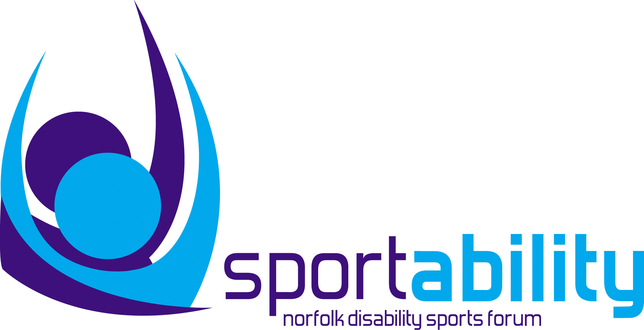Sportability Child Registration Form

Sportability is a project in Norfolk looking at increasing sporting opportunities for children with disabilities from around the County. We are looking at developing our own database of children to enable us to contact you with forthcoming events and activity. If you would be interested in being part of our database please fill out the form below and return to: Jen White, Norfolk Education Advisory Services, Turner Road, Norwich, NR2 4HB. If you have any queries please do not hesitate to contact Sportability on: 01603 727 888 or via email: jen.white@norfolk.gov.uk

About you
Name: ………………………………………………………………………………….. ……… Male Female
Age: ………………………………………………………………..Date of birth: …………………………………………………………..

Address: …………………………………………………………………………………………………………………………………………………

……………………………………………………………………….. Postcode: …………………………………………………………………….

Home Telephone number (including STD): ………………………………………………………………………………………..

Contact & Medical Information

Name of parent/guardian/carer: ………………………………………………………………………………………………………..

Daytime Tel: ………………………………………………………… Mobile tel: …………………………………………………………….

Other medical conditions we need to be aware of: ………………………………………………………………………….

………………………………………………………………………………………………………………………………………………………………………..

Your doctor’s surgery & number: …………………………………………………………………………………………………………….

Please tell us the nature of your disability
This will help us organise the most appropriate training sessions

Physical impairment Learning difficulty
Hearing impairment Visual impairment
Other (please specify)…………………………………………………………………………………………………………………………

I would like to receive a copy of the Sportability Newsletter YES NO

The details on this form will be used by Sportability to inform you of other activities. All information will be kept confidential and will not be passed on to any other party, in accordance with the Data Protection Act 1998.

