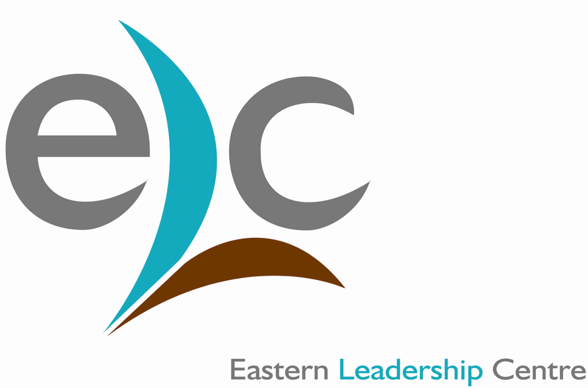
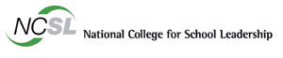
A programme that is still fully
Government funded*
Certificate of School Business Management

For the attention of Bursars, Administrators and all prospective and current School Business Managers
You are invited to attend

A ‘TASTER’ SESSION
…for this highly successful national qualification. It is designed for bursars and school business managers wishing to take an active part in leading effectiveness and efficiency improvements in their schools. It addresses development in relation to the school’s
context and therefore, is, a practical way of meeting schools’ and bursars’ needs.

This is an exciting and innovative programme that is accredited by the Institute of
Administrative Management with their Diploma, which is acknowledged internationally and confirms its status.

Beyond this 6 - 11 month programme, the emerging School Business Managers may wish to apply for enrolment onto the DSBM (accredited with IAM Advanced Diploma) and later to the BA (School Business Management) which together represent the three years of a vocational top up degree.
“Better trained, highly motivated bursars, acting at a sufficiently senior level, play a key role in improving school standards”
Heather du Quesnay, NCSL Chief Executive
“I found the programme very exciting and motivating. It’s enabled me to develop my role – I now have a more strategic input into the running of the school, looking at long-term financial management, the school rebuilding project and fund-raising”
CSBM Graduate, Essex
“This course has been one of the most difficult things I have done, but it is also one of the most rewarding and worthwhile experiences I have had. Although there have been many ups and downs, I have thoroughly enjoyed this challenging course and want this learning process to continue. I am looking forward to applying for the DSBM.”
CSBM Graduate Lancashire
The Certificate of School Business Management is a Programme of the
Taster Sessions will be held across the region (see overleaf), please come and learn about the qualification. Tea and Coffee will be available from 9.30am, the session will run from 10.00am – 11.30am.

The application round for Cohort 9 is now open. The closing date for applications and the letter of support is 26th January 2007. Further details and application forms are available at www.ncsl.org.uk/bursar

* For state Schools
Date | Venue | Please Tick
Monday 8th January 2007, 10.00 - 11.30am | Barnham Broom Hotel, Norwich
Wednesday 10th January 2007, 10.00 – 11.30am | Holiday Inn, Ipswich
Certificate of School Business Management

For the attention of Bursars, Administrators and all prospective and current School Business Managers
You are invited to attend

A ‘TASTER’ SESSION
Taster Sessions will be held across the region (see overleaf), please come and learn about the qualification.

The application round for Cohort 7 is now open. The closing date for applications and the letter of support is 16th December . Further details and application forms are available at www.ncsl.org.uk/bursar

* For state Schools
“I found the programme very exciting and motivating. It’s enabled me to develop my role – I now have a more strategic input into the running of the school, looking at long-term financial management, the school rebuilding project and fund-raising”
CSBM Graduate, Essex
“This course has been one of the most difficult things I have done, but it is also one of the most rewarding and worthwhile experiences I have had. Although there have been many ups and downs, I have thoroughly enjoyed this challenging course and want this learning process to continue. I am looking forward to applying for the DSBM.”
CSBM Graduate Lancashire
…For this highly successful National Qualification. It is designed for bursars and school business managers wishing to take an active part in leading effectiveness and efficiency improvements in their schools. It addresses development in relation to the school’s
context and is therefore a practical way of meeting schools’ and bursars’ needs.

This is an exciting and innovative programme that is accredited by the Institute of
Administrative Management with their Diploma, which is acknowledged internationally and confirms its status.

Beyond this 6 - 11 month programme the emerging School Business Managers can apply for
enrolment onto the DSBM (accredited with IAM Advanced Diploma) and later to the BA (School Business Management) which together represent the three years of a vocational top up degree.
A programme that is still fully
Government funded*
The Certificate of School Business Management is a Programme of the
“Better trained, highly motivated bursars, acting at a sufficiently senior level, play a key role in improving school standards”
Heather du Quesnay, NCSL Chief Executive
Certificate of School Business Management

For the attention of Bursars, Administrators and all prospective and current School Business Managers
You are invited to attend

A ‘TASTER’ SESSION
Taster Sessions will be held across the region (see overleaf), please come and learn about the qualification.

The application round for Cohort 7 is now open. The closing date for applications and the letter of support is 16th December . Further details and application forms are available at www.ncsl.org.uk/bursar

* For state Schools
“I found the programme very exciting and motivating. It’s enabled me to develop my role – I now have a more strategic input into the running of the school, looking at long-term financial management, the school rebuilding project and fund-raising”
CSBM Graduate, Essex
“This course has been one of the most difficult things I have done, but it is also one of the most rewarding and worthwhile experiences I have had. Although there have been many ups and downs, I have thoroughly enjoyed this challenging course and want this learning process to continue. I am looking forward to applying for the DSBM.”
CSBM Graduate Lancashire
…For this highly successful National Qualification. It is designed for bursars and school business managers wishing to take an active part in leading effectiveness and efficiency improvements in their schools. It addresses development in relation to the school’s
context and is therefore a practical way of meeting schools’ and bursars’ needs.

This is an exciting and innovative programme that is accredited by the Institute of
Administrative Management with their Diploma, which is acknowledged internationally and confirms its status.

Beyond this 6 - 11 month programme the emerging School Business Managers can apply for
enrolment onto the DSBM (accredited with IAM Advanced Diploma) and later to the BA (School Business Management) which together represent the three years of a vocational top up degree.
A programme that is still fully
Government funded*
The Certificate of School Business Management is a Programme of the
“Better trained, highly motivated bursars, acting at a sufficiently senior level, play a key role in improving school standards”
Heather du Quesnay, NCSL Chief Executive

Certificate of School Business Management

East Region Taster Application
Your name (please print clearly) ......................................................................................................

Your school name and address .......................................................................................................

...........................................................................................................................................................

............................................................................................ Post code............................................

Phone number ....................................................................Fax .....................................................

e-mail address ................................................................................................................................

School phase e.g. Primary: ...........................................................................................................
Please tick the session you would like to attend and return the form to the Eastern Leadership Centre.

Confirmation of your place will be sent by email with a map to the venue.

Please e-mail, post or fax this reply slip to CSBM, Eastern Leadership Centre, Peterhouse Technology Park, Fulbourn Road, Cambridge, CB1 9AH.
Tel: 01223 271724, Fax: 01223 271770, e-mail: michelle.collen@elc-cambridge.org
or alternatively you can complete the form online at our website www.elc-cambridge.org

