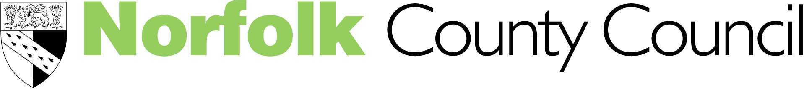
Children’s Services

Therapeutic Storywriting

For Teachers working with primary aged children, Psychologists, those with a Counselling background

Storywriting sessions can be done with individuals or small groups of primary aged children. There is often a positive impact on literacy participation and attainment, as well as helping the development of emotional literacy.

Date: 1 March 2007 - 9.00- 4.00 pm

South Green Park, Mattishall

Keynote speaker: Trisha Waters
Trisha Waters, Senior Lecturer in SEN, developed therapeutic storywriting through her teaching in mainstream and special schools, including a therapeutic community for boys with severe emotional & behavioural difficulties
Cost £115.00 (including lunch).

Cheques payable to Norfolk County Council (although we would prefer you to pay by Journal transfer)
Please complete the slip below if you would like to attend and return with your payment or Journal Number
…………………………………………………………………………………………………………………………………………………

I would like to attend the Therapeutic Storywriting Conference

Name ………………………………………………………………………………………..

Title ………………………………………………………………………………………….

School/Address ……………………………………………………………………………

………………………………………………………………………………………………..

Please indicate any special dietary requirements ………………………………………

Please return your reply slip to: Heather Haycox, The Terrapin, Hewett School site, Cecil Road, Norwich, Norfolk NR1 2TJ by 21st February 2007 or email heather.haycox@norfolk.gov.uk. If you require further details contact Rita Adair on rita.adair@norfolk.gov.uk. (Tel: 01603 671400) or jane.sarmezey@norfolk.gov.uk


