
Children’s Services
Norfolk Music Service
Professional Development Centre
Woodside Road
Norwich, NR7 9QL
Telephone: 01603 433276
Fax: 01603 708074
E-mail: mailto:music.service@norfolk.gov.uk

CHANGE TO PUBLISHED INFORMATION – NEW TIME

Vocational GCSE in Rock Music
Thursday 27th April 2006

Just when you thought there was no other GCSE option – Access to Music will be presenting 3 GCSE packages that have been accredited through NQF specifically for rock and pop music.

Package 1 (Performing Musician): Level 2 Award, Equivalent to 1 GCSE (A-C*), 12 Credits at Level 2
Package 2 (Creative Music Producer): Level 2 Award
Equivalent to 1 GCSE (A-C*), 12 credits at Level 2
Package 3 (Performing Musician – GCSE alternative): Level 2
Certificate equivalent to 2 GCSE’s (A-C*), 24 Credits at Level 2

The session will be a presentation led by Sue Ball, Head of Curriculum, Access to Music (ATM). Sue leads on ATM’s 14 –19 alternative curriculum, Performing Musician and Creative Music Producer courses.

Please note that this course is now FREE to all applicants and will run as a 1 hour demonstration at 4.00pm venue to be decided.
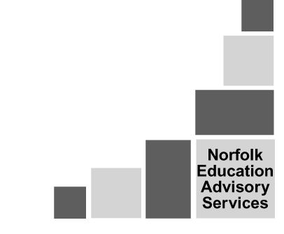



---------------------------------------------------------------------------------------------------------------

Reply Slip

Name ___________________________ School_______________________

Contact Number_________________________________________________

I will be attending the Vocational GCSE in Rock Music demonstration on Thursday 27th April 2006 at 4.00pm

Signed _______________________________________________________

Please return this slip to Norfolk Music Service, Professional Development Centre, Woodside Road, Norwich NR7 9QL or telephone Lynne Wright to book your place on 01603 433276 E-mail: mailto:music.service@norfolk.gov.uk

