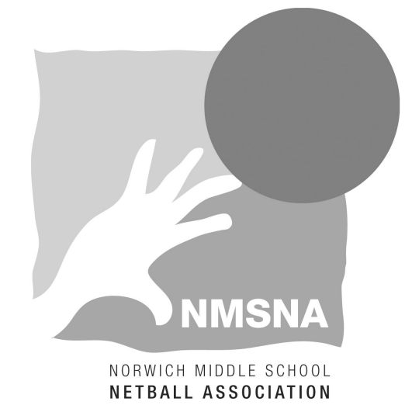NORWICH MIDDLE SCHOOL NETBALL ASSOCIATION

c/o
South Harford Community Middle School
Locksley Road
Norwich
NR4 6LG

E-MAIL:mailto:tony@southharford.norfolk.sch.uk

NETBALL TOURNAMENT 2006

U.E.A SPORTSPARK, TUESDAY 28TH MARCH
RESERVE THURSDAY 30TH MARCH

2 AGE GROUPS, YEAR 7 AND YEAR 6

FULL NETBALL RULES, NOT HIGH 5’s

ENTRY: £5 PER TEAM.

Please make cheques payable to SOUTH HARFORD MIDDLE SCHOOL.

Closing date for entries WEDNESDAY 1ST MARCH.

Please e-mail your return to the above address with the following information;
SCHOOL NAME
YR GROUPS ENTERED
MONEY SENT
SKIRT
SHIRT
BIB
TEACHER CONTACT
ARE YOU RETURNING A TROPHY
DRAW, RULES ETC WILL BE SENT OUT AFTER THE 1ST MARCH.

SEE YOU THERE I HOPE, IF YOU NEED TO TALK TO ME ABOUT ANY ISSUES TUESDAY AND THURSDAY ARE THE BEST DAYS.

Love to all

Tony

