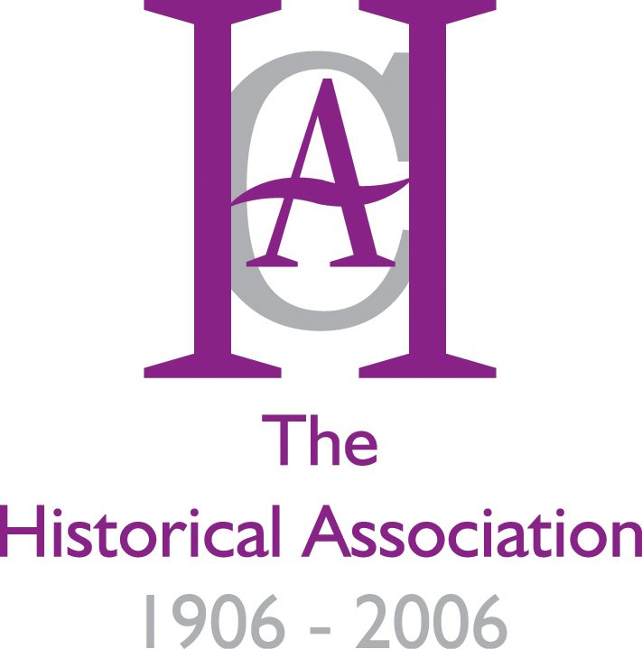

2006 as you may know is the Centenary of the Historical Association. The very first meeting of the HA was on May 19th 1906. As part of our Centenary celebrations we are holding a Centenary Primary day at the Roots of Norfolk Museum, Gressenhall, on Saturday May 13th 2006.
Primary History in the Classroom
Roots of Norfolk Museum, Saturday, 13th May 2006

Situated in a big old workhouse, and with a working farm and collection of rural life, Roots of Norfolk is an ideal venue to explore issues in primary history. Tim Lomas will give the keynote talk, drawing on all his wide experience of the primary field, and there will be a dozen workshops on Key Stage 1 and Key Stage 2 issues to choose from. Andrew Wrenn will highlight Transition [Key Stage 2 – 3] issues, building on our successful ‘transition’ project this year in Cambridgeshire, helping to bridge the gap between KSt2 and KSt3, where Secondary Heads of History have been working with their primary colleagues to develop history skills in Year 6. There will be workshops on, amongst others, Toys, Homes, and Learning from Objects, for KSt1, and the Victorians, Teaching the Holocaust, WW2, Tudor Explorers, and Local History for KSt2. Other workshops are yet to be finalised.

Building on successful conferences in the last couple of years, this is a largely practical 'hands on' day to help colleagues develop their classroom skills. The day will start at 10.00, and finish by 3.45, leaving plenty of time to explore the museum after the day is over. Cost is £40, including lunch. Further details and a booking form are available from alf.wilkinson@history.org.uk

Alf Wilkinson

HA Professional Development Manager

BOOKING FORM

Name and Title ………………………………………………………………………………...

School ..........................................................................................................................................

Contact address you would like us to use for mailings:

…………………………………………………………………………………………………..

…………………………………………………………………………………………………..

…………………………………………………………………………………………………..

Telephone: Daytime ……………………………… Evening ……………………………..

Email address (Work) ………………………………………………………………………...

Email address (Home) ………………………………………………………………………..

(We generally use email, but may need to telephone you about the arrangements at some point)

Please tick the appropriate boxes below:

I enclose my cheque for £40.00
Please debit my credit card number (details below)
Card No. …………………………………………. Expiry date ………………………
Please send an invoice for £40.00, quoting reference …………………………………

Signature …………………………………………. Date …………………………….

Please return to: Alf Wilkinson, 33 Hall Road, Great Hale, Sleaford, Lincs, NG34 9LJ
(01529 460553) Email: mailto:alf.wilkinson@history.org.uk

