
June 14th, July 4th, 5th 2007
10 am – 2.30 pm
Canary History Day
A Joint Event
Canary History Day
A Joint Event

Focus on Football
to investigate changes in Britain since 1948
■             
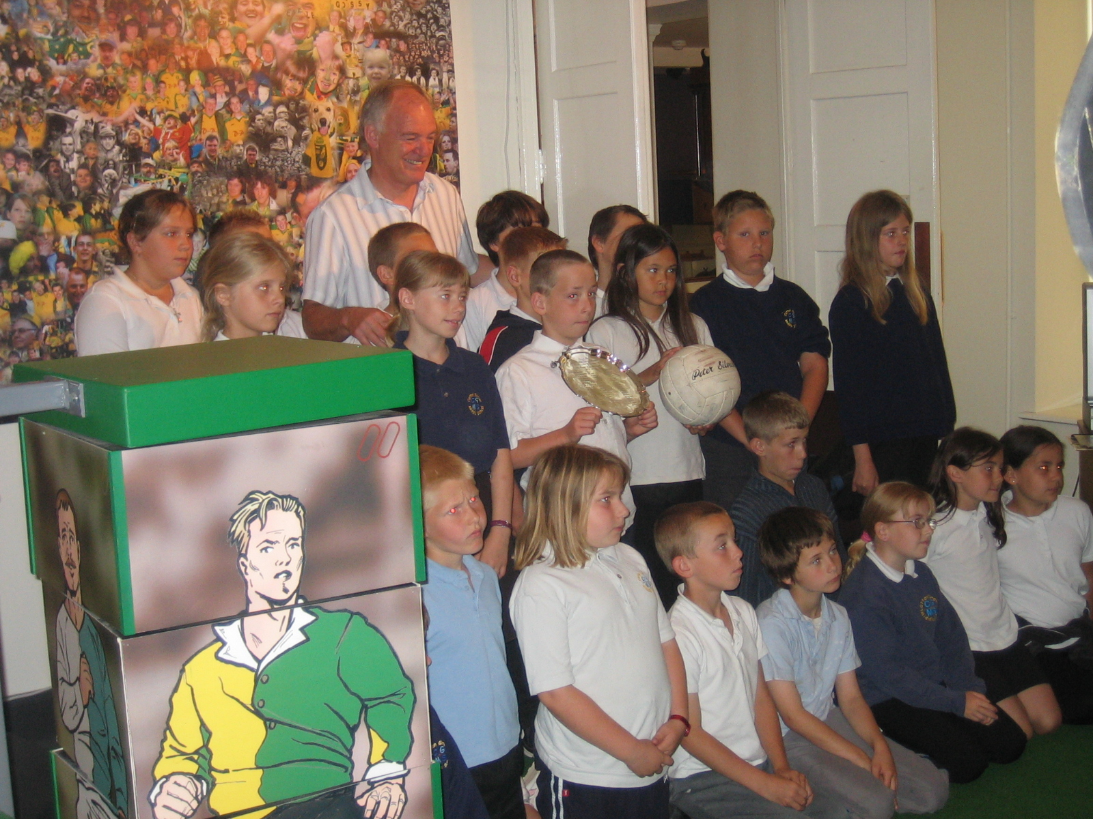
Explore the ‘On The Ball City’ Exhibition at the Bridewell Museum to find out about Canary history.
■             
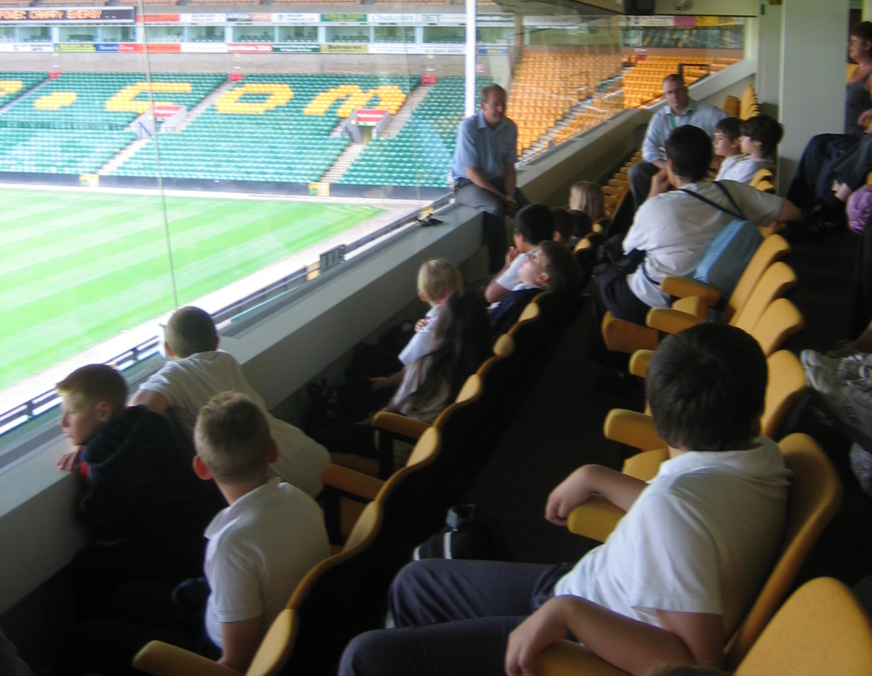
Tour Norwich City Football Club and meet Club Staff to learn about the Canaries today.
Research and answer questions using objects, photos, interviews and videos.


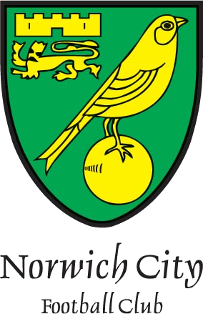
Cost: £5 per child, free to all accompanying adults.
To book call 01603 493636

