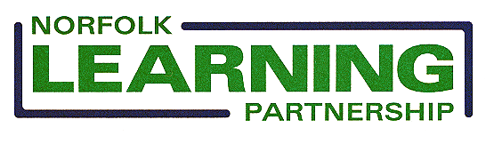

Young People Participation Survey

The Norfolk Learning Partnership been asked to map the activity which provides a voice for young people across the county and would be grateful if you could provide the following information and return to Andy Hodgson by e mail at andy.hodgson.nlp@btconnect.com by 27/4/07 please.

School/Organisation :
Do you have a student council or other group which allows the views of young people to be heard? Yes/No

If Yes please can you provide the information below
What is the structure of the group and the frequency of meetings?

What is the purpose of the group?
What are the expected outcomes for the group?
What are the benefits to your school or organisation of having the group?
Has the group the ability to effect change in your school or organisation? If so can you give some examples?

