Autumn Term - Special Events
Welcome to our autumn newsletter. You're now just a click away from some great learning events on offer in our museums over the next few months.
Norfolk County Council Schools get free admission to our museums and we can sometimes help with transport costs . There is a modest charge for special events and workshops.
If you would like to join our e-mailing list and receive regular news updates, you can sign up on our web site at www.museums.norfolk.gov.uk Don't forget to click on 'schools programme' in the interests section.

Norwich Castle
A Day with the Romans and Iceni KS2
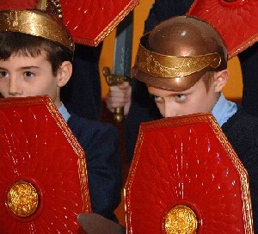
Spend a day with costumed characters, learn to be a Roman soldier, make an Iceni torc and find out what life was like under Roman occupation. Click here for more info.
Storming the Castle: A Maths Investigation KS3
Give KS3 Maths a real life context in this thought-provoking workshop. Students explore how Norwich Castle could be attacked and defended using maths skills to investigate questions like how much water was in the well and how much food would be needed to survive a siege. Click here for more info.

Gressenhall Farm and Workhouse
Homes or Habitats? Geography Investigation KS3
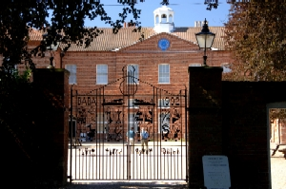
Students get to the heart of a planning enquiry to decide if houses should be built on the Gressenhall site. Interaction with characters in role promotes lively debate tackling contemporary issues. Click here to find out more.

Waste Free Lunches at Gressenhall
Thousands of students visit our museum every year and eat their lunch on site. To try to reduce the amount of waste generated from packed lunch boxes, we're working with the School Waste Action Club (SWAC). Click here for more information and to download teachers' notes and templates showing how to promote waste free lunches to parents and carers.

Lynn Museum
Hunting Horace Foundation & KS1
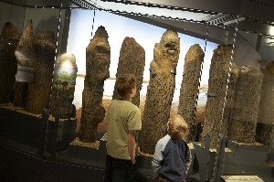
Pretend to be on safari and find the animals in the museum. Hear a story, feel the textures of different animals, explore animal noises and make an animal mask to take home.
Seahenge Stories KS1
Meet a Bronze Age storyteller and find out about Seahenge. Create simple poems and make a Bronze Age pot to take home.
Stolen from Seahenge KS2
Attend a 'trainee journalist's conference' and get caught up in a mystery! Investigate the disappearance of an object from the gallery, interview staff from the museum and write a newspaper report.
Click here to view the special events programme for Lynn Museum and the Town House

Great Yarmouth Museums
Time and Tide and the Elizabethan House
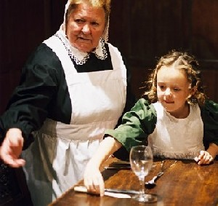
There are some super learning events on offer this term. Highlights include Victorian Servants Day, Tudor Christmas, Evacuee Experience and the all new Bringing Home the Herring.
Click here to view the full programme of events for primary schools
Click here for details of our new KS3 Geography event

