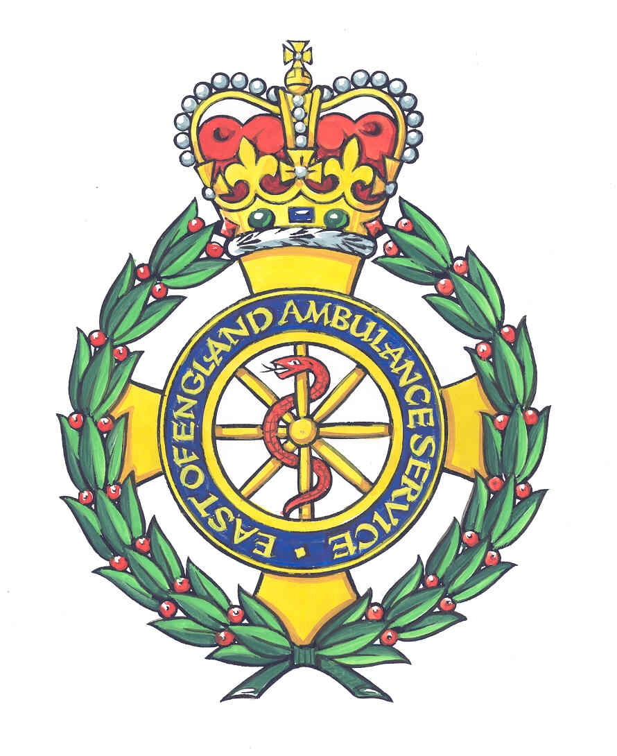
Jeanne Reynolds
Heartstart Schools Co-ordinator, in association with:
East of England Ambulance NHS Trust

E-mail jeanne.reynolds@btinternet.com
Tel: 07796 031299

FREE Heartstart UK Schools Training AND Resources !

Dear Colleague,

The Heartstart UK Schools’ Programme is an initiative coordinated by the British Heart Foundation (BHF) and provides an opportunity for pupils age 5 and over to learn simple Emergency Life Support skills to enable them to keep someone alive in an emergency until professional help arrives.
This programme is available to all schools to support and complement your PSHE curriculum and Healthy Schools initiative

The programme is usually delivered by teachers or other school staff who attend a day of free training to become Heartstart UK instructors. (the cost of supply cover for up 4 teachers to attend this training day is paid for by the BHF)
All training materials for the schools, manikins DVD’s etc. Are supplied FREE by the BHF

Currently there are 1900 schools across the UK (108 Schools in Norfolk) that deliver the Heartstart UK Schools Programme.
The programme can be delivered in two different ways:

- a series of age related staffed sessions for pupils age 5 years and over
- a complete, stand alone, practical course for pupils age 10 years and over. The course can be divided into a number or units/sessions or delivered in a whole session.

If you are interested in running the Heartstart UK programme in your school please fill in and return the proforma . The next training day to be held is on Friday 15th May
Any further queries please do not hesitate to contact me.

Yours sincerely

Jeanne Reynolds
Hearstart Medics Norwich
Scheme Co-Ordinator

Supported by




Expression of Interest to run the Heartstart UK Schools Programme in School

SCHOOL:

Name of person to contact:

Telephone:

Email:

Training Dates:

Friday 15th May 2009 at:
Roundwood Bowls Club, 44 Ringland Road, Taverham, Norwich. NR8 6HY
08.45 – approx 15.45. Lunch is provided

Please note that the programme should not be delivered in school until notice of affiliation has been received from the British Heart Foundation. This may take up to 8 weeks from when the forms are posted. You will receive assistance with the affiliation forms on the training day.

If you are interested in taking part in this worthwhile scheme or would like more information please contact me or return this form to:

Jeanne Reynolds
Hearstart Medics Norwich
3, Wensum Valley Close
Norwich
Norfolk
NR6 5DJ
Tel: 07796 031299
Email: jeanne.reynolds@btinternet.com

Supported by

