Norfolk’s War Project

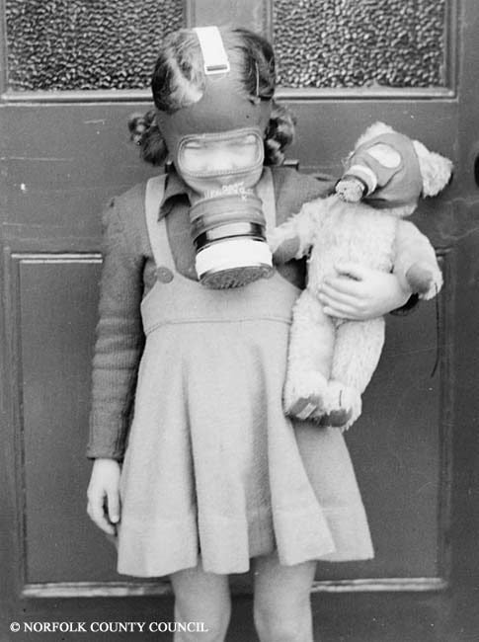

New Learning Resources for Schools

Norfolk Museums & Archaeology Service and BBC Voices have been working with students from Cliff Park, Oriel, Neatherd, Springwood and Park high schools to create some exciting new learning resources for schools.

We have created five short “radio programmes” about life in wartime Norfolk using interviews with people who lived through the war.

You can find these in the Gallery section of the E2BN website at -

http://gallery.nen.gov.uk/gallery13918-e2bn.html

There is also a selection of archive images linked to each programme.

For further information contact: colin.stott@norfolk.gov.uk


