The ‘Open the Book’ Project aims to:
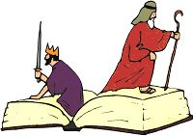
- present the Bible in an accessible, enjoyable way
- enable every child to hear the story of the Bible during their primary years
- encourage links between schools and churches in a local context
- equip, encourage and enable adults to work with children in schools in an appropriate way

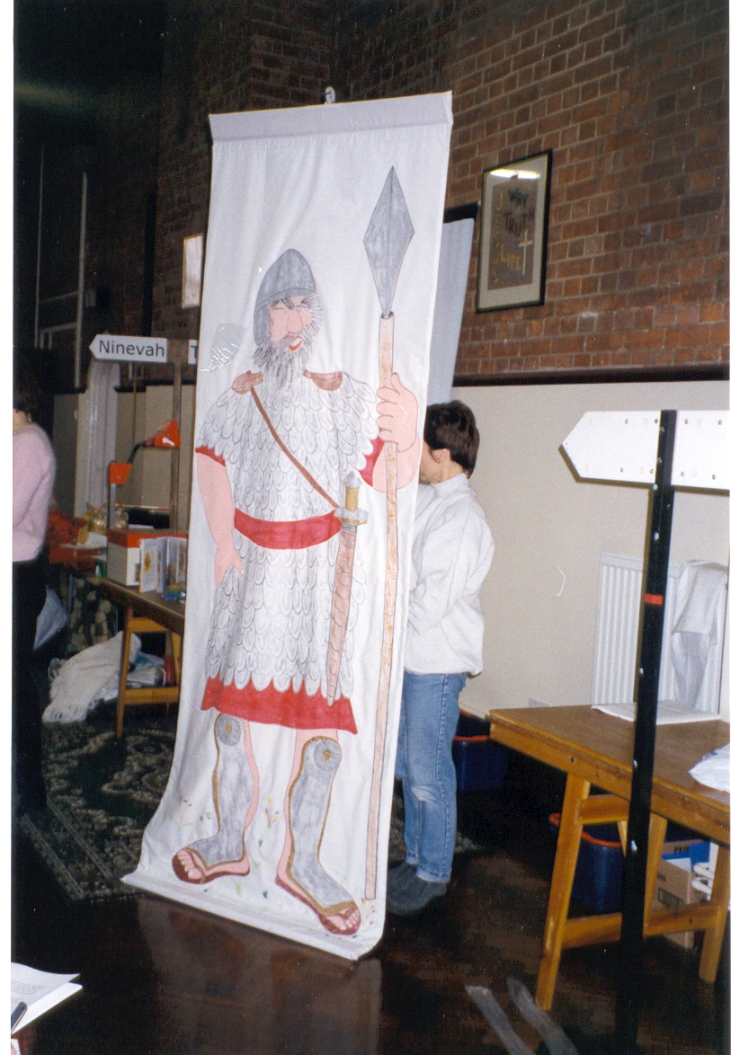
"Open the Book" began as a series of 30 Bible stories presented weekly in school assemblies. It was an initiative developed first in 1999 with the support of Churches Together in Bedford and offered free of charge to the local primary schools. Thousands of children across the country now hear Bible stories from ‘Open the Book’ teams. Around 1600 teams are in place nationally, including a number in East Anglia.

The storyteller team for each school is made up of volunteers from local churches which are encouraged to work together. The storytellers have a “how-to-do-it” booklet written by an experienced teacher to reflect the nature of school assemblies and also a simple code of conduct which states that they agree to:
- use the structure and form of words given in the handbook
- liaise closely with their local school, for example, over timing
- prepare the stories to the best of their ability
- show respect & sensitivity to those of other faiths, and of none

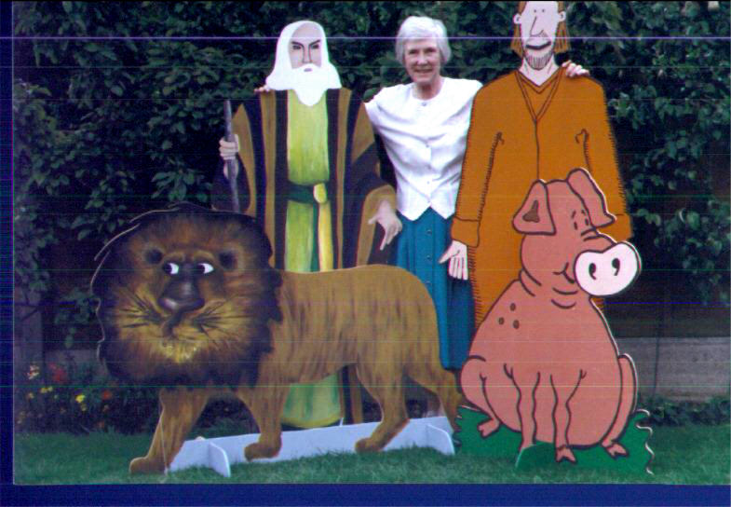
The stories are based on the Lion Storyteller Bible by Bob Hartman, a Bible story book recommended for use in RE in primary schools across Norfolk and Suffolk. The stories last about 8-10 minutes and give a 'snapshot' of the Bible from Genesis to Acts. There is now material for a 3 year programme.

Many stories use high impact visual aids and simple drama. Props and costumes are made locally, often by older church members, and in some areas stored centrally and shared by several teams.

You can find out more by visiting the OTB website:
www.openthebook.net

Norwich Diocese is hosting two training sessions on 19th September at Harleston Primary School and 14th November at Swaffham Junior School (tbc) and would ask you to encourage, cajole, even bully (nicely) your local church members (whatever the denomination) to sign up for either of the above dates. A third date is possible at Diocesan House, Easton but yet to be arranged.

