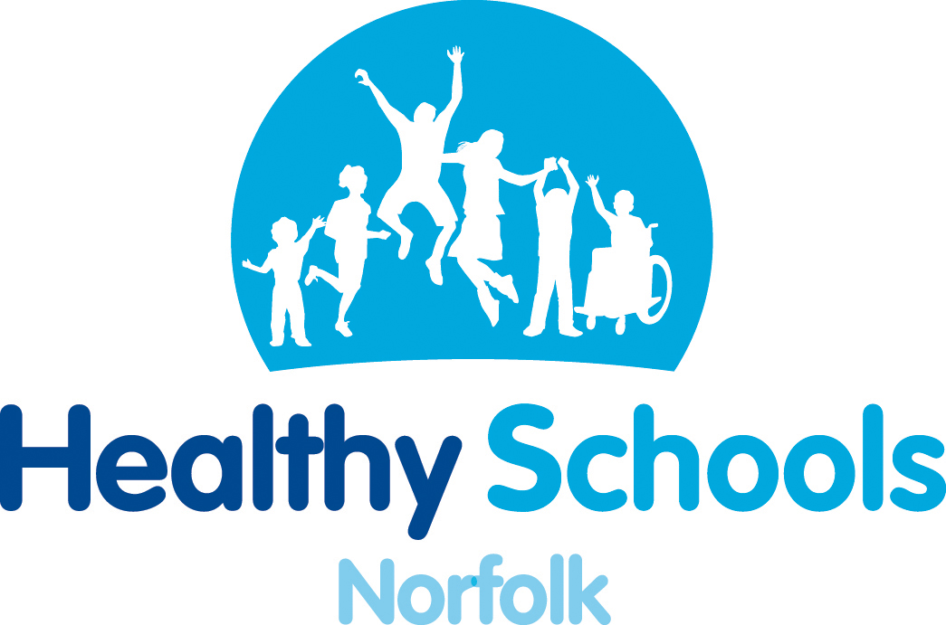
Healthy Norfolk Schools has been working with British Red Cross to offer this FREE first aid CPD opportunity to secondary schools.
It is suitable for:
- Key stage 3 & 4 teachers of PSHE, PE, Science, Duke of Edinburgh and ASDAN
- Teachers of other subject areas which include some first aid.
- Teaching assistants

No previous experience of first aid is necessary

.
Helping teachers build a generation of life-savers!

Norfolk CPD Date: 8 July 2010 Time: 2 - 4pm

Venue: British Red Cross, Coronation Road, Norwich, Norfolk, NR6 5HD
Following this workshop, participants will be able to deliver some basic first aid education to students as required by the key stage 3 & 4 PSHE curriculum.

Objective:
- To give participants the confidence and resources to teach some basic first aid to students including decision making skills and the recovery position.

What you’ll take away:
- A ‘Life. Live it.’ CD ROM with two first aid lessons covering: staying safe, making an emergency call, the recovery position, CPR, bleeding, and shock. These lessons are on PowerPoint supported by videos, worksheets and an interactive quiz, all with accompanying lesson plans and schemes of work. (There is also the option to buy a full ‘Life. Live it.’ first aid education kit with 10 lessons and practical materials for £135)

The workshop will cover:

- The contents of the ‘Life. Live it.’ first aid education kit
- Tips for teaching basic first aid, including decision making skills and the recovery position
- Links between first aid education and drugs and alcohol education
- Exploring barriers to teaching first aid
- Other resources and services available from the British Red Cross

The ‘Life. Live it.’ First aid education kit was designed in consultation with teachers and provides an easy to use and flexible resource. It’s been specially designed to enable all teachers to feel confident in delivering first aid education, even those unfamiliar with the subject. This workshop will give you the confidence to teach some basic first aid using ‘Life. Live it.’ resources - appropriate for key stages 3 and 4 but easily adapted for other groups.

How to get there:
By Road
From A11, turn left onto A47 Southern Bypass, signed Swaffham. Pass exit for B1108. Leave at exit for A1074 (Travel Inn/Sainsbury’s) and turn right towards Norwich – see below.

From A47, leave at exit for A1074 (Travel Inn/Sainsbury’s) and turn left toward Norwich – see below.

Then from both, at second roundabout, turn left into ring road. Go straight past four traffic lights. After fourth traffic light, take first left into City View Road (Whiffler PH on corner), then first right into Coronation Road.

Car Parking Details
There is ample on-site parking (at own risk). You are encouraged to remove radios and valuables, and to secure your vehicle.

Places are limited to 20 and will be allocated on a first come, first served basis so please complete and return the attached booking form. For further information please contact Marian Fox on 01603 221810 or marian.fox@norfolk.nhs.uk
(Please note that although this is a free CPD opportunity, there is no supply cover available.)

Please FAX back to

MARIAN FOX
01603 221835



Red Cross first aid CPD opportunity for secondary schools.

BOOKING FORM:

School: ____________________________________________________

Title:

First name:

Surname:

Email address:

Telephone Number:

Access requirements:

We will try to accommodate two delegates per school where possible
Title:

First name:

Surname:

Email address:

Telephone Number:

Access requirements:

Please forward booking form to:
Marian Fox
Fax – 01603 221835
Post – Healthy Schools, Kestrel House, Hall Road, White Lodge Business Park, Norwich, Norfolk, NR4 6DG
Email - marian.fox@norfolk.nhs.uk
Call - 01603 221810

