
FREE French, German and Spanish
Language Improvement Sessions
are coming to a venue near you!

French

Spanish

German
Summer term 2010

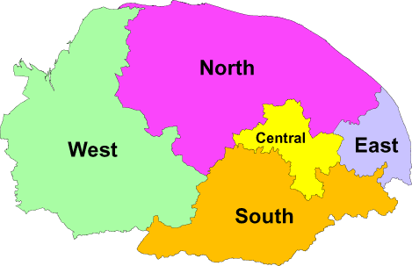
I’m much more confident to speak in front of the class.*
Really enjoyable. Just the right level with lots of ideas for games and songs.*
To register on any of the above, please complete the attached form and return to –
lisa.poploski@norfolk.gov.uk *comments from delegates on 2009 courses

* 9 hours of language tuition full course (FC) * 4½ hours half course (½C)

* sound files for personal pronunciation practice * examples of good primary languages methodology

* resources for classroom use * revision of core topics of vocabulary, based on Early Start 1 and Rigolo 1

* certificate of attendance on completion of the course

 |  | Area | Ref | Venue | Date | Time
FRENCH | FC | South | EPQA9 Z | Queensway Junior School, Thetford IP24 3DP # | Wed from 5.5.10 | Refreshments from 4pm -4.30pm  Courses run from  4.30pm-6pm  Subsequent weeks will be on the same day of the week; dates and times will be agreed with the group  Half courses run  on alternate  weeks
 | FC | Cen | EPQA6 G | NPDC, Woodside Road, Norwich NR7 9QL | Tues from 11.5.10
 | FC | West | EPQA6 H | WNPDC, Kings Lynn PE30 2HU | Tues from 11.5.10
 | FC | South | EPQA6 J | Preston CE VE Primary, Tasburgh NR15 1NU | Tues from 11.5.10
 | ½C | North | EPQA6 K | Bure Valley Primary, Aylsham NR11 6JZ | Wed from 12.5.10
 | ½C | West | EPQA6 L | Duchy of Lancaster CE VE Primary, Methwold  IP26 4PP | Thurs from 13.5.10
SPANISH | FC | South | EPQB1 R | Queensway Junior School, Thetford IP24 3DP # | Wed from 5.5.10
 | FC | Cen | EPQB1 S | NPDC, Woodside Road, Norwich NR7 9QL | Tues from 11.5.10
 | FC | South | EPQB1 T | Pulham Primary School, Pulham IP21 4SZ | Tues from 11.5.10
 | FC | North | EPQB1 U | Fakenham Junior School, NR21 8BN | Wed from 12.5.10
 | FC | West | EPQB1 V | WNPDC, Kings Lynn PE30 2HU | Wed from 12.5.10
 | FC | East | EPQB1 W | Rollesby Primary School, NR29 5EH | Thurs from 13.5.10
 | ½C | North | EPQB1 X | Bure Valley Primary, Aylsham NR11 6JZ | Wed from 19.5.10
 | ½C | West | EPQB1 Y | Duchy of Lancaster CE VE Primary, Methwold  IP26 4PP | Thurs from 20.5.10
GERMAN | FC | West | EPQD4 J | WNPDC, Kings Lynn PE30 2HU | Tues from 11.5.10
 | ½C | Cen | EPQD4 K | NPDC, Woodside Road, Norwich NR7 9QL | Thurs from 20.5.10
# Sessions at Queensway Junior School run from 4.00 pm – 5.30 pm

ENROLMENT FORM FOR FRENCH / SPANISH / GERMAN

LANGUAGE IMPROVEMENT SESSIONS

Name:

Position: Please tick
Headteacher |  | Teacher |  |  | HLTA |  |  | TA
Currently working in year(s): Please tick
R | 1 |  | 2 | 3 |  | 4 | 5 |  | 6
School:

Contact Number:

I wish to reserve a place on the following course:

Date of first session | Venue | Language | Course Ref
Subsequent dates and times of the above will be given out at the first session

Please tick level of spoken French / Spanish (language chosen above)
Very rusty ‘A’ level | Rusty ‘O’ Level / GCSE | Poor to None
Other Details –

Please note that this course is for beginners and is not aimed at confident speakers.

Signed: | Date:
Headteacher Signature: | Date:

Please return as soon as possible:
Lisa Poploski, Children’s Services, Norwich Professional Development Centre, Woodside Road, Norwich NR7 9QL or Fax 01603 700236

