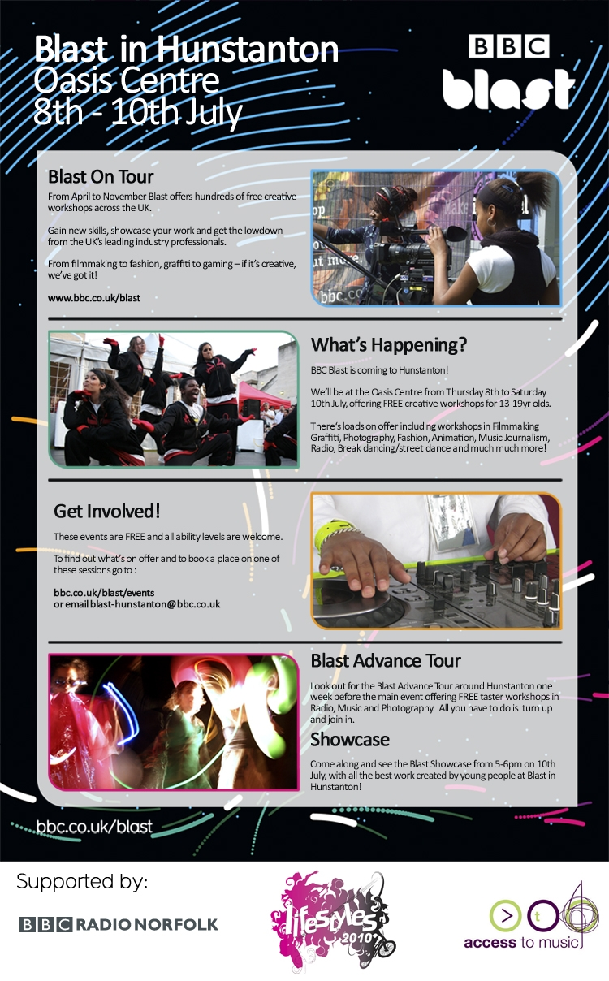

Workshop Booking Form for [Name of School] on [Date]
Please read this sheet carefully, sign it and return the original to the address below. Participation cannot take place unless this document has been signed and received by the BBC.
The BBC has established Blast to provide an exciting environment for creative learning. Please read the following information as it contains important details (including health and safety) that you, your staff and your pupils should be aware of before your visit to Blast. The health and safety of all visitors to Blast is of paramount importance. The BBC has taken all reasonable steps to provide a safe environment for all visitors and staff. Nonetheless, you, your staff and pupils should be aware that;
- The conduct of your staff and pupils must be appropriate at all times.
- The BBC has public liability insurance in place, but you must adhere to all requirements (including that of the LEA) for school visits of this type.
- The BBC has a Child Protection Policy and procedures in place, there is first aid cover and the truck is equipped with emergency equipment.

Staffing and Supervision of pupils
Your group must have a ratio of at least 1 adult to every 10 pupils - following LEA guidelines. The staff at Blast are provided by the BBC as facilitators and guides only.
- You and your staff shall be responsible for your pupils, their conduct and safety whilst at Blast.
- Your staff/any accompanying adults should remain with the pupils/young people at all times throughout the visit and shall follow all instructions (including health, safety and security instructions) given to them by BBC staff at Blast.
- The BBC reserves the right to refuse access to Blast and to require your staff and pupils to leave the site (e.g. in the event of an emergency, for conduct reasons or otherwise).

Arrival
There is wheelchair access to the truck - please telephone in advance if you have any specific requirements. On arrival, your group will be met at the Blast site reception area (yellow gazebo). You should bring with you all the signed consent forms for each young person who is participating in the workshop and allow time for registration before the start of the workshop.

Food & Drink
There will be breaks during workshops. Full day workshops will include a break for lunch. Pupils and staff should provide their own lunch. Blast does not provide refreshments except drinking water.

Clothing & footwear

Workshops take place indoors and outside, please wear suitable footwear and clothing for the activity you are taking part in.

Informing parents
You shall be responsible for obtaining prior written consent from each pupil's parent/guardian for the visit to Blast. The Blast consent form should be completed and signed by the parent/guardian for each young person attending. This consent form includes permission to attend the event and to submit work as part of BBC Blast. It also enables the BBC to use and broadcast work created during the workshop and to document your activity to use for publicity and broadcast purposes.

Cancellation policy
A cancellation fee of £50 is payable if a workshop booking is cancelled within seven working days of its scheduled date. If this happens, we will invoice you.

After your visit
Your comments and thoughts are of tremendous value to Blast and BBC Learning. We would really appreciate you/your staff taking time to send us feedback on your visit. We may wish to contact you in the future for research purposes and to update you on Blast and other BBC projects. Please tick this box if you do not wish to be contacted. ◻
Please tick this box if you do not wish to receive the Blast Newsletter. ◻

We look forward to welcoming you!

Name of school: | Workshop name(s):
Name of Contact: | Workshop date(s):
Contact email: | Workshop time(s):
Contact number: | Number of pupils:
I have studied this document and am satisfied with all aspects -

Name of Headteacher:

Signature of Headteacher: | Date:

