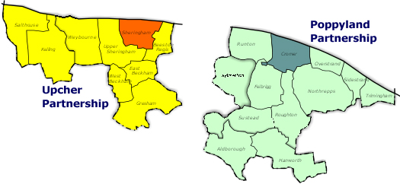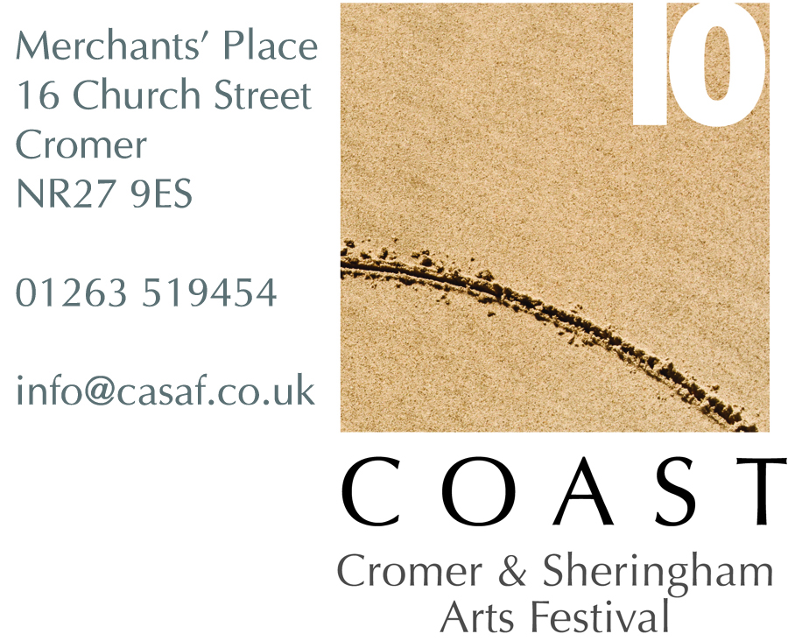
Artists, Writers, Musicians and Performers in the COAST Area

This is your LAST CHANCE to become pro-active and get involved in
COAST Cromer and Sheringham Arts and Literary Festival 2010

As you can see from the website at www.casaf.co.uk a great framework of events has already been organised for this exciting 9-day event in October; and there are several other interesting opportunities currently being explored

ARTISTS MEETING at The Village Inn West Runton on Friday 16 July, 7pm
If you would be interested in meeting the organisers, finding out more and discussing your ideas, please RSVP to rosieglasgow@googlemail.com by Monday 12 July latest
NB: if there is insufficient active interest, this event will not happen.

COAST ART ROADSHOW: August-Sept
To access and involve outlying villages, and give opportunities to artists for community involvement, it has been suggested that a series of roadshow events in village halls be initiated in the run up to the festival. The idea is to take over a village hall for a day, invite the public, and get the place buzzing! Art disciplines could include: Music for All, Big Draw, Make & Show Fashion, Explore the Environment, Film for Fun, Poems & Storytelling, Performance & Circus Skills, Micro Worlds, Printmaking etc. Artists/performers will be paid a daily fee (to be decided).
To Register Interest Email Janet Farrow contact@upchercp.co.uk

UNUSUAL ART IN UNUSUAL PLACES: 23-31 October
If you want to open your studio... this is for you!
But Also... If you can display/perform your work in a cafe or shop, a beach hut, tent or caravan, bus shelter, allotment, cellar, ballroom, shop window, flagpole, fish tank, shoebox, whatever... This is for you! Your details and venue will appear in 5000 “COAST: Unusual Art in Unusual Places” brochures, and in any relevant publicity. Signage will be available to download.
Deadline for Entries: 12 August Fee: £20 per venue
Entry Form and Details Attached
NB: if there is insufficient active interest, this opportunity will not happen.

BIZARRE BAZAAR: 28 October, 10am-4pm in Cromer Community Hall
A great chance to sell your work, fashions, jewellery as well as old art materials, china, seashells, clothing, collectables etc etc etc! Only 25 pitches available on a first come first served basis.
Fee: £10 per pitch
Booking Form and Details Attached

2 MINUTES OF YOUR TIME
Your chance to make a film which will be premiered during the festival; unusual and eccentric ideas more than welcome! Deadline 20 Sept 2010 Full details at www.2minutesofyourtime.co.uk

BIZARRE BAZAAR – BOOKING FORM

28TH OCTOBER 2010 10am – 4pm

(Deadline for receipt of applications 1st October 2010 (booking form and payment)

25 pitches available on a first come, first served basis)

- YOUR DETAILS – Please answer in BLOCK CAPITALS
NAME |  | TRADING NAME (If any)
ADDRESS |  | PHONE
 |  | MOBILE
 |  | EMAIL
POSTCODE |  | WEB ADDRESS

OUR DETAILS: Email: captainkate82@hotmail.com Web: www.casaf.co.uk
Cromer and Sheringham Arts Festival, Merchants’ Place, 16 Church Street, Cromer, NR27 9GW
Phone: 01263 519454 Fax: 01263 510708

- YOUR ART
Please give full description of all stock you will be displaying
Your booking will be taken on the basis of what you list here:

- PAYMENT – Please tick the relevant box to indicate your preferred payment option
- I ENCLOSE A CHEQUE IN THE SUM OF £10
(made payable to Cromer and Sheringham Arts and Literary Festival)

- PAYMENT BY CASH IN THE SUM OF £10
(Accepted IN PERSON ONLY at Merchants Place)

- YOUR REQUIREMENTS (please tick the relevant boxes)
6FT table £10
Electricity will be supplied (subject to availability) at no extra charge.
If you require electricity PLEASE TICK BOX

If you have any further special requirements e.g. extra display units (clothes rails etc) – please note them here. While we will do our best to meet any special requests, we cannot guarantee doing so.

- DECLARATION
I HAVE READ AND ACCEPT THE TERMS OF BOOKING

PRINT NAME: SIGNATURE: DATE:

CONDITIONS OF BOOKING
BIZARRE BAZAAR
CROMER COMMUNITY HALL
28TH OCTOBER 2010

- CROMER COMMUNITY HALL
Bizarre Bazaar will take place in Cromer Community Hall. Bizarre Bazaar will be advertised as part of COAST – Cromer and Sheringham Arts Festival. A4 event posters will be made available upon request. Each participant will be provided with a 6ft table (subject to availability) and two chairs. Electricity, where requested and available will be provided at no extra charge.

- ALLOCATION OF TABLES
In order to provide an opportunity for a variety of stalls at the fair, one table per participant will be allocated in the
first instance. Subject to availability, a second table may be available a little nearer the time, although this is not
guaranteed. Bookings will be taken in strict order of receipt. We aim to ensure as wide a variety of products are on
sale as possible to our customers. COAST festival therefore reserves the right, should it be necessary, to decline an application.

- PARTICIPANT OBLIGATIONS
All tables to be set up by the advertised start time. Access to the Community Hall can be gained between 8.30am and 5.30pm. Bizarre Bazaar will be open to the public between 10.00am and 4.00pm. You are not to clear away until the advertised finishing time. All tables to be set up in an attractive manner and participants to supply a suitable table covering to cover the top of the table. You must not attach anything to walls or ceilings in a way that will leave marks and you must leave your table area clean and tidy at the end of the day. You should specify if you require electricity for equipment when booking.

- PAYMENT
Full Payment, required in advance of the event, will be accepted by cash or cheque. Cheques should be made
payable to ‘Cromer and Sheringham Arts Festival’ and cash payments will be accepted in person only at the
Merchants’ Place along with the booking form.

- CANCELLATION OF BOOKINGS
Cancellations will be accepted up to TWO weeks before the date of the fair but will be subject to a £5 administration fee. Any booking cancelled at less than TWO week’s notice before the fair, for whatever reason, may forfeit the total table fee paid even if the table be re-let. If you are unable to attend you must let us know as soon as possible. Cancellations may be advised by phone but must be confirmed in writing.

- PARKING
You will be able to unload outside the Community Hall in Garden Street subject to available parking. Once unloaded, you must immediately move your vehicle to a suitable location.

- LIMIT OF LIABILITY
We will do everything in our power to ensure that you have a successful day but cannot be held responsible for
damage or theft of your stock, interruption of power or services, failure of press advertisements to appear or
anything else beyond our control. COAST festival does not provide insurance cover for theft or damage to your stock and recommends that you adequately insure yourself against all risks. It is a condition of booking that
you understand and accept that you cannot hold COAST festival or Cromer Community Hall responsible for any losses you sustain.

- FIRE AND EVACUATION PROCEDURE
Please refer to the documents at Cromer Community Hall upon arrival at Bizarre Bazaar on October 28th 2010.

- REFRESHMENTS
Tea, coffee and biscuits will be available for purchase throughout the day.

COAST: Unusual Art in Unusual Places

1. Your details (to be published in the brochure, please adapt for groups)
First name/s: |  | Surname/s:
Telephone/s: |  | Email/s:
Address and directions to your studio or venue:
Website/s:

2. Opening times – Try to have consistent opening times (eg: 11am-5pm)

Sat. 23 | Sun. 24 | Mon. 25 | Tues. 26 | Wed. 27
Thur. 28 | Fri. 29 | Sat. 30 | Sun. 31

3. Image for brochure: 1 JPEG Only Please (300 dpi not larger than 1.5mb), for abstracts, indicate top.
4. Wheelchair Access: Y or N.
5. A bit more about what visitors will see (20 words max.)

6. Future Events for November- December (It may be possible to add some extra events after the festival. Please detail here)

7. I have read the COAST Terms & Conditions (see next page) and agree to them for my participation in the “Unusual Art in Unusual Places” Brochure

Nominated Signature Name Date

Please print and return this form with your £20 fee to: Cromer and Sheringham Arts & Literary Festival, c/o Merchants Place, 16 Church St, Cromer NR27 9ES
And MOST IMPORTANT also Email this completed form with your JPEG to: coast.unusual@gmail.com before 12th August 2010

COAST: UNUSUAL ART IN UNUSUAL PLACES Terms & Conditions

1. Eligibility: The scheme is open to all artists working in any medium and living or working within the COAST, Cromer and Sheringham Arts Festival area.

2. Opening to the Public: Your commitment is to open your studio/venue to the public, exhibit/perform your work, and be present to discuss it during the days and hours indicated on your application form.

3. Non-Studio Venues: You are responsible for negotiating with your venue owner/provider if it is not your own studio or space. We advise you have an agreement/booking in writing.

4. Fee: The fee for entering the “Unusual Art in Unusual Places” scheme is £20. Please make cheques payable to Cromer and Sheringham Arts and Literary Festival. COAST is not taking any commission on sales/entry fees made during the event (a particular venue may take a commission).

5. Application Form: Applications must be filled in and fees paid for every venue, fee can be split if participating as a collective.

6. Deadline: The deadline for applications is 12 August 2010. Applications received after this date will not be entered into the Brochure. Applications are deemed received when all necessary documents and payment have been received.

7. Data Protection: Your personal details will be stored on a computer of the COAST Festival organisers. We will not pass your details to third parties without your consent. You accept that details you provided in the application form in the section “1. Your details (to be published in the brochure)” will be published.

8. Images: Images supplied with the application form must comply with the requirements listed in the form.

9. Brochure: Entries will be collated by the organisers, who also reserve the right to edit text supplied for use in promoting the scheme. Whilst every effort will be made to ensure the accuracy of information included in the brochure COAST organisers cannot be held responsible for any omissions or mistakes which occur. Each artist will receive copies of the brochure for distribution to their mailing list. We will provide downloadable flyers and signage.

10. Insurance: Artists opening their studios are responsible for their own insurance cover including public liability. This may or could be covered in artist’s personal home or business insurance, but each participant should check with their insurance. Each artist has a responsibility to ensure the safety of their visitors. COAST Arts Festival organisers do not accept any liability for visitor safety. Artists are responsible for the insurance of their work at all times.

11. Safety: Artists exhibiting at home should make sure that they are with someone to help them at all times. For your own safety, it is not advisable to have an Open Studio at your home on your own.

11. Non-Event: If there is not enough interest in this scheme, it will not happen. Your cheque will be returned to you.

APPLICATION CHECKLIST
□ | Application form filled in on-line sent to: coast.unusual@gmail.com
□ | Digital picture of one work for brochure (by email only please)
□ | Application form printed out to send with your cheque
□ | Cheque for £20 payable to Cromer & Sheringham Arts & Literary Festival

