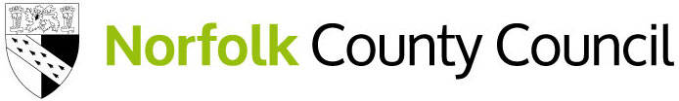

Recovery Premium Grant 2023-2024
Recovery premium grant funding is intended to support education recovery following the impact of the COVID-19 pandemic. The grant for Children in Care is managed by the Virtual School Head in consultation with schools.
Recovery Premium Grants are available to schools where there is a Norfolk Child in Care on roll. A setting can make one application in an academic year. Each application will be considered on an individual basis and in some cases a contribution will be considered rather than the full amount.

Grants are available to support the following:
- High quality teaching
- Targeted academic support
- Wider strategies – SEMH, attendance, extracurricular activities

Expectations of the grant:
- That the grant benefits more than one child (one of those being a Norfolk Child in Care)
- Is supportive of either high quality teaching, targeted academic support and/ or wider strategies
- Is not used to fund a salary/ part of a salary for an employee
- Completion of a Case study to evidence impact

Examples of successful applications:
- SNIP reading programme purchase
- Mathletics subscription
- ELSA training
- Sensory Room Development
- ADHD training
- Bereavement training
- Year 1 continuous provision enhancement
- Sensory success
- SCERTS programme
- DESTY
- Development of literacy spaces
- Gardening Project
- Two year Thrive subscription package

Timetable for applications
Term | Application deadline | Panel meeting
Autumn 1 | Monday 16th October | Wednesday 18th October
Autumn 2 | Monday 11th December | Tuesday 12th December
Spring 1 | Monday 12th February | Wednesday 14th February
Spring 2 | Monday 25th March | Wednesday 27th March
Summer 1 | Monday 20th May | Wednesday 22nd May
Summer 2 | Monday 8th July | Wednesday 10th July

If you would like to apply for the grant, please speak to your Virtual School Adviser. If your application will be for an amount exceeding £3000 please contact Hannah Collison Smith to discuss prior to an application being submitted h.collisonsmith@norfolk.gov.uk
Once you have spoken to a Virtual School Adviser, please use the link below to apply.
https://forms.norfolk.gov.uk/service/recovery-premium-grant-application
Once you have submitted an application a PDF copy will be forwarded to the email address you provide.
If you have any questions, please email virtual.schools@norfolk.gov.uk

