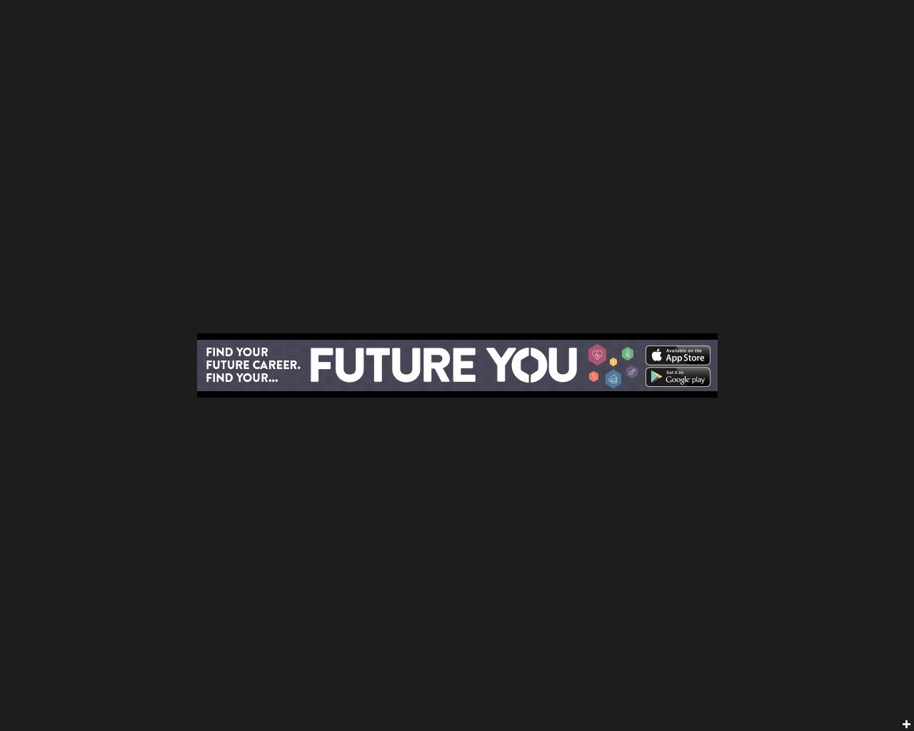

**New Future You Careers Tool**

**for year groups 7-13 now available online**

**Click here to access the Web Tool today**

**app.futureyounorfolk.com**

Aimed at young people aged 13 to 21, the campaign includes the launch of a free online careers tool which helps young people match their skills and aptitudes to the county’s likely job market.

The tool has been designed by young people for young people and offers advice on:

* career paths
* academic courses
* interview techniques,
* work experience
* CV writing,
* job roles,
* apprenticeship

The tool is perfect for young adults and students looking to work out what they want to do as a career in Norfolk.  All they need to do is simply plug in their top three skills, interests and aptitudes and the tool will work out which jobs are best suited to their ability.

Future You Web tool is ideal for Careers advisors – no need now to rely on smartphone access!

Perfect for:

* students in Year 8 choosing their GCSE options
* students in Years 10 and 11 choosing their post-16 options and
* students in Years 12 and 13 choosing next steps after further education or initial training

**Mobile Careers App aims to get young people working in Norfolk’s six growth sectors**

Young people in Norfolk are being urged to think about careers in the county’s six growth industries as part of a new interactive campaign aimed at developing Norfolk’s future workforce.   
  
Norfolk County Council has launched the Future You campaign to help address a skills gap in the county and boost the aspirations and careers of young people living in Norfolk. 

**Now available online and also via the App Store and Google Play (search Future You Norfolk)**

**What next?**

Please promote the Future You web tool to all students and parents.

Please include reference to Future You in school newsletters

The Future You careers app is now available online at app.futureyounorfolk.com – so if you do not have access to smart phone this is ideal

There are also 60 second and 30 second films available at <http://www.norfolk.gov.uk/Childrens_services/Schools/Future_You/index.htm>

**Coming Soon**

Future You promotional pack including leaflets and posters to help promote the careers tool at school at your careers sessions

**For More Information**

**Please contact** [**marketing@norfolk.gov.uk**](mailto:marketing@norfolk.gov.uk)

**Or visit the Future you website** [**www.futureyounorfolk.com**](http://www.futureyounorfolk.com)