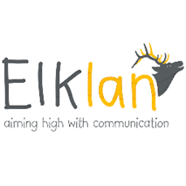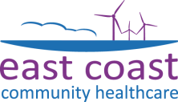25th

**Wednesdays 9.45 – 12.15**

**10 weeks 25th September, 2nd Oct, 9th Oct, 16th Oct, 6th Nov,**

**13th Nov, 20th Nov, 27th Nov, 4th Dec, 11th Dec (this session 1.30-4.00pm)**

**At Ayton House, 11 Ayton Road, Wymondham, NR18 0QQ**

**11th Dec ( please note this will be 1.30pm – 4.00pm**

**Ayton House, 11-17 Ayton Road , Wymondham , NR18 0QQ**

**Communication**

**Support for Verbal Pupils with Autism**

**Spectrum Disorder**

**(ASD)**

**Provides information and strategies to develop the communication skills of children with autism or social communication difficulties at primary and secondary level**

**Participants will receive A Level 3 or Level 2 nine credit Award in Knowledge and Practice to Support the Communication skills of ASD**

**Uses interactive teaching methods, practical activities, videos and group discussion to engage learners**

**Cost**: **£390 (including VAT) per delegate**

(includes ten x 2.5 hour training sessions, marking of portfolios, accreditation fee and the Language Builders book)

To apply, please email ECCH.SALTtraining@nhs.net

Your place will be confirmed once we have received your completed application form

For further information, contact us:

**ECCH.SALTtraining@nhs.net**

**01493 808630**

An accredited course for those working with pupils who have social communication needs including Autism Spectrum Disorder (ASD). It is suitable for staff working in mainstream, special schools and specialist units empowering them to develop the communication skills of pupils who need help to

use their language within a social context.

The course is delivered over 10 weeks (each session lasts two and half hours). You will complete a portfolio, adding to it each week; this will help to put into practice what you learn on the course. Participants will receive a Level 2 or Level 3 nine credit Award in Knowledge and Practice to Support the Communication Skills of 5-11s – both levels are now on the Qualification and Credit Framework. A portfolio of evidence will need to be submitted. Visit [www.Elklan.co.uk](http://www.Elklan.co.uk) for more details.

Speech and Language Therapy Services