**SEND Leaflets Order Form**

A set of six leaflets has been designed for families who have a child with special educational needs and disabilities (SEND), as a friendly introduction to the following key aspects of the Children and Families Act 2014.

* Joint commissioning
* The Local Offer
* Special educational needs (SEN) support
* Education, health and care (EHC) plans
* Personal budgets
* Preparing for adulthood

To order all or any of the SEND leaflets, please complete the order form below.

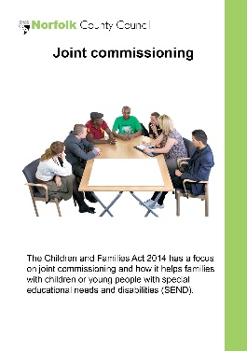  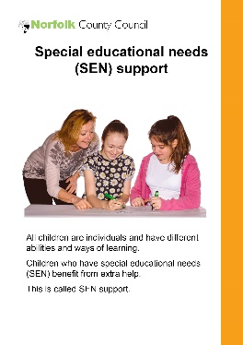

**Quantity: Quantity: Quantity:**

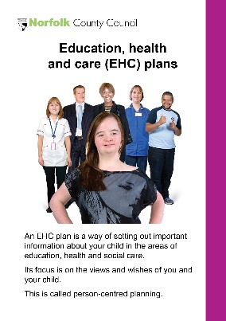  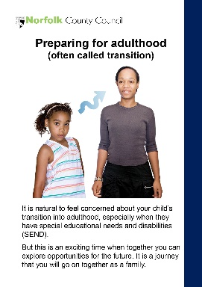

**Quantity: Quantity: Quantity:**

Please tell us the quantity you require of each leaflet and return your order form back by:

**Email**: [send@norfolk.gov.uk](mailto:send@norfolk.gov.uk)

**Post**: Children’s Services - Education Inclusion Service, Floor 3 – Bay 15/16, Norfolk County Council, County Hall, Martineau Lane, Norwich, NR1 2DH