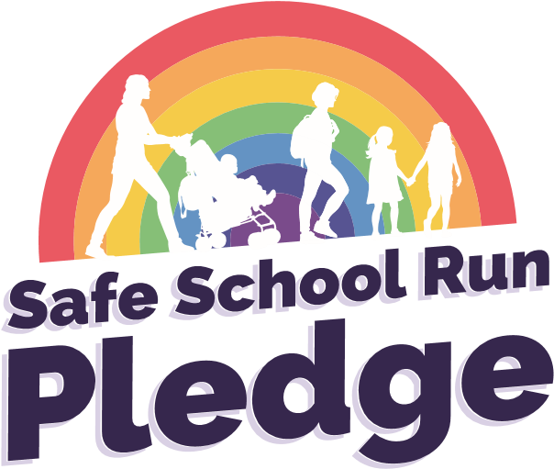
The aim of the ‘Safe School Run Pledge’ is to promote responsible parking which will help keep our children safe when they are dropped off or picked up outside the school.
The school led scheme is delivered with full support from Norfolk County Council
Road Safety Team and Norfolk Constabulary and Norfolk Fire and Rescue Service. Our intention is to work closely with you to highlight and increase parent/carers understanding of the importance of safe and considerate parking outside your school.

To take part
If you are interested and would like to take part in this new Safe
School Run Pledge initiative please email roadsafety@norfolk.gov.uk
for a resources pack

