

Committed to making schools a safe and welcoming place for all.

We help students, teachers and our wider communities to understand what it really means to be **seeking sanctuary**.

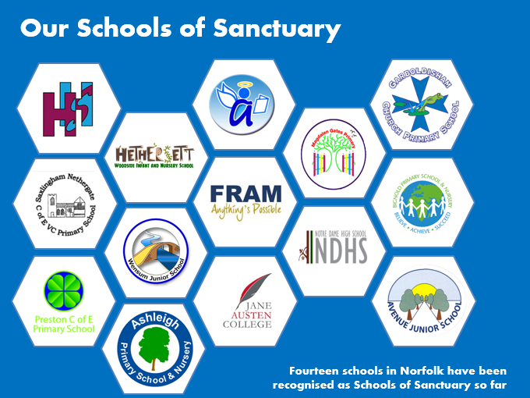A school of Sanctuary is a school that aspires to make everyone feel safe, included and welcomed. They have an ethos which sees everyone as equal, valued members of their community. Promoting inclusion and celebrating diversity are an integral part of this journey and we are fortunate to have 14 Schools of Sanctuary in Norfolk leading by example by sharing and spreading their good practice.

There are 3 steps to becoming a School of Sanctuary

**LEARN**

Develop a whole-school approach to learning about what it means to be seeking sanctuary and how to provide a welcoming environment.

**EMBED**

Take positive action to embed concepts of welcome, safety and inclusion within your school and the wider community.

**SHARE**

Be proud! Share your vision and achievements and take an active part in the Schools of Sanctuary network

To find out more, visit the website: [Norfolk Schools of Sanctuary (norfolksos.co.uk)](https://www.norfolksos.co.uk/)