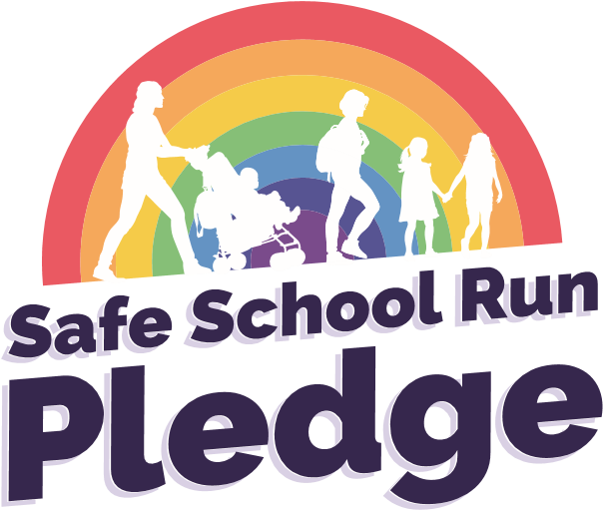
The aim of the ‘Safe School Run Pledge’ is to promote responsible parking which will help keep our children safe when they are dropped off or picked up outside the school encouraging safe and active journeys.

The school-led scheme offers flexibility in delivery, with advice support and guidance from the Norfolk County Council Road Safety Team and Norfolk Constabulary and Norfolk Fire and Rescue Service. Our intention is to support you to highlight and increase parent/carers understanding of the importance of safe and considerate parking outside your school whilst encouraging safe and active journeys.

We supply a great resources pack with everything you need to run the Pledge in your school.

To take part
If you are interested and would like to run your own Safe School Run Pledge initiative, please email roadsafety@norfolk.gov.uk

